Meme Assignment

Summer Warmack

02/02/2023

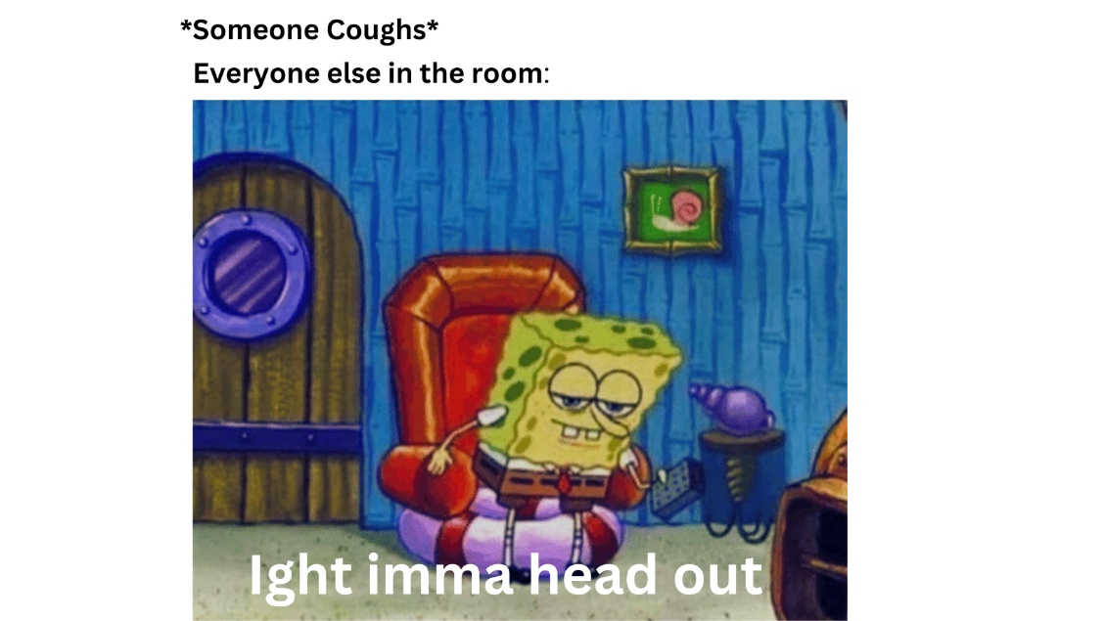 I decided to choose this meme because I feel like it describes everyone’s behavior during this time. This behavior was so strong that people still do it today (myself included). COVID-19 was definitely a shock to people when it started coming around. I was a freshman in college when the coronavirus started to get attention. I remember going into the dining hall in the morning to eat breakfast and watching the news anchors talk about how the coronavirus might become a pandemic, which it did. The next semester we went home for spring break and we did not come back to campus until fall 2021. East Carolina University tried to do in person classes in the fall of 2020, but it did not work because cases on campus were too high.

Description says everyone coughs in a room, then follows with an action made by everyone in the room. The action is described by a picture of SpongeBob getting up from his chair with words in the picture saying “Ight imma head out.”

During this time period, which was peak COVID-19, coughing was a very common symptom of COVID and everyone knew it. With that being said, if you were in the grocery store, or anywhere in public around people, and you coughed or anyone else did, everyone would look at you funny. People would rather move far away from you or just leave because people automatically assumed you had COVID. The reason people assumed was because someone can have COVID and not even realize it. At this time the most telltale sign of COVID was trouble breathing, but you could have the symptoms of a common cold and it turn out to be COVID. People were very cautious about this because COVID spread very easily. This was before a vaccine was even an option, so many people were genuinely scared of getting this virus, so they were not taking any chances. Even if everyone had masks on in a store, I guarantee that if someone coughed in a store at this time, most people would react by leaving or getting away from that person. The funny part of this is because someone could just be clearing their throat and people would assume you had COVID.

The last point I want to go over is that even to this day, which is 2023, people will still get very cautious when they hear someone cough in public. We have vaccines and boosters now, so you would think that people would have a peace of mind, but it is not true. I am not sure if it is because people are still genuinely scared on getting COVID or if reacting that way to a cough has become natural to all of us. Some people are still cautious because some of the population do not have the vaccine for COVID-19 because there is speculation whether the vaccine has caused or is causing people harm in some ways. This makes other people cautious because there is no way of knowing whether someone is vaccinated or not unless they tell you. However, most people are not very worried about COVID-19 anymore. Sometimes it can feel like it never happened.