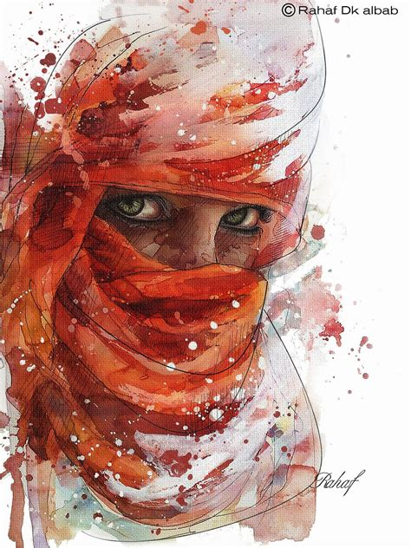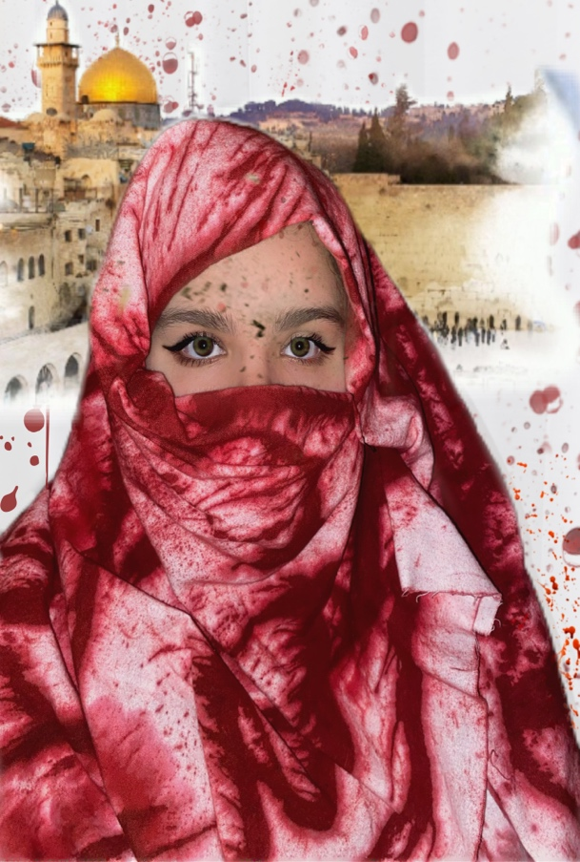

Hi everybody, my name is Hannah Shannak, I am a freshman biology major here at ECU. My intent after achieving a bachelor’s degree in biology is to continue furthering my education and becoming a physician’s assistant. My interest in the arts began in simpler times as a toddler; I would sit by my radio in my bedroom and wait for songs like, "Hey There Delilah", and, "Wagon Wheel", to come on as I obnoxiously sang and danced to other top hits at the time. Dancing was just a fun get up of mine, but singing was and is still my most enjoyable past time. As for my background, I am a biracial eighteen-year-old who comes from a Jordanian father and a North Carolinian mother.
My cultural experiences in life have been gifted to me from my father’s half of the family, some members of which are also Palestinian. Inheriting a historic and beautiful culture also includes being educated on the history of our origins. As some of you may know, there has been constant war between Israeli and Palestinian governments beginning roughly 30 years prior to Israel being established as an official state in 1948. The conflict has been continuous, resulting in brutality aimed at Palestinian citizens by Israeli soldiers, destruction of homes/schools/hospitals, thousands of innocent everyday citizens lives stolen, I could go on, but I digress.
For my imitation, I purchased a three-and-a-half-yard piece of white fabric, red cloth dye, and a squeeze bottle from the craft store. I had no special technique in dying the fabric, I simply had the fabric hanging and splattered the red dye on the fabric then preceded to dry it. While the fabric was dying the inside of my dryer red, I applied eye makeup to imitate the woman's eyes in the painting. In my perception of the painting, the woman's eyes are one of the main focal points; her pristine white hijab appears to be drenched in a concerning amount of blood, there is blood splatter on her face, but peeking out are her rare, dramatic green eyes. I wanted to accentuate the same kind of effect in my imitation, so I put on eyeshadow that almost exactly matched my skin tone, black eyeliner to create the same dramatic effect as the woman's eyes, and mascara. After the makeup was complete, I draped the dyed fabric around my head in the style of a loosely fitted hijab, pinning it on the left side with a hair barrette.
My acknowledgement of what is happening in Palestine is what lead to my choosing to complete the Imitating Artwork Challenge for my project. The painting I chose was composed by Rahaf Dk Albab, a 30-year-old middle eastern artist. The only title for her painting that I was able to find is "Arab Woman Portrait", it was done circa 2014. The aesthetic of this painting was very appealing to me! This woman's head is covered in someone’s blood, a beautiful lady with the rarest eyes, yet famish and blood drench her.
The affects you see in my imitation were done in the application PicsArt. Rahaf seems to have used watercolor paint to create her artwork, rather than adding a watercolor affect, my inclusion of adding blood splatter in the surrounding area and on my face seemed fitting. Before finalizing my photograph, I sent my father the image, he suggested that I include the Al-Aqsa Mosque, located in Jerusalem, into the background, I gladly agreed with his suggested addition, and feel that this was the perfect inclusion to finish off my imitation.

