COVID-19

Department of English, East Carolina University
ENGL 1100 Foundations of College Writing
Dr. Cheryl Dudasik-Wiggs
Spring 2021

COVID-19
This paper will provide a generalized description of my experiences throughout the COVID-19 pandemic. I will begin by giving some brief background information. My mother became pregnant with my little sister in February of 2020, just before the COVID-19 pandemic began. This would be her first child since my younger sister passed away due to stillbirth in November 2006, making my mom apprehensive about complications even without the additional risks COVID-19 presents.
My sister’s father made it clear that he would not provide support throughout my mom’s pregnancy or after, so that responsibility fell upon me. I was happy to help my mom as she has always been there for me, but the responsibility proved to be a sizeable challenge. At the time, I was still attending high school, applying for college and scholarships, and working part-time, all during a widespread pandemic, so I had to develop some excellent time management skills. My mom was classified as a high-risk pregnancy, meaning she had weekly Dr’s appointments an hour from home and several long nights at the hospital when there were any scares, all of which I accompanied her to.
COVID-19 presented several challenges throughout this process, including canceling the remainder of my senior year, adding wait times at hospitals and doctor’s appointments, and making appointments scarce, meaning we would have to adjust our schedules around them instead of vice versa. COVID also added significant stress on my mother, as it can be particularly dangerous for pregnant women and their unborn children. In addition to all of this, covid regulations closed gyms, meaning my previously active lifestyle morphed into the life of a couch potato, causing me to gain 40 pounds by the end of 2020. All of the sacrifices my mother and I made throughout her pregnancy seemed entirely worth it when my sister, Lilly, was born in July of 2020 with no complications.
I left for college soon after, although the “college experience” was limited and short-lived, as it has been for most students during the COVID-19 pandemic. ECU sent everyone home after three weeks of classes, limiting students to online instruction for the remainder of the school year. This was a massive letdown for most of us, but if the decision saved even one life, it was entirely worth it.
The adjustment to online instruction was a tough one for me. In my opinion, it’s significantly easier to stay focused and motivated when interacting face to face. Moreover, it isn’t easy to build relationships with friends and professors when the only source of interaction is through email or discussion boards. Despite the downfalls of learning online, there is a silver lining to being home for the school year. I’ve been able to watch Lilly grow for the first year of her life and assist my mom in any way I can. Helping my mom has been incredibly fulfilling, as I’ve seen how difficult it was for her to raise me with no assistance.
COVID threw a curveball at my family in mid-February 2021, when Lilly, who was then six months of age, contracted COVID-19, along with myself, my mom, and my grandfather, who was in the ICU for two weeks with the illness. This was a huge scare, as infants’ immune systems are fragile, and my grandfather was very high risk due to old age. To add to the turmoil, the most significant ice storm in years came through my hometown, leaving us with no power or heat in sub-freezing temperatures while dealing with COVID. We all had severe symptoms, mine being the mildest, and instead of the sick-day experience I had growing up in a warm home with my mom taking care of me, I now had to ignore my symptoms and take care of my sister in a dark, cold house. This was an incredible challenge with no ability to travel due to downed trees and ice-covered roads. I got no work done while the power was out, leaving me with piles of missing work to catch up on over the following weeks. Those weeks were some of the most challenging of my life, but they weren’t nearly as awful as they could have been if I had lost my sister, mother, or grandfather.
Despite the struggles and downfalls, I’ve grown a tremendous amount from these experiences. I’ve learned the value of responsibility and accountability, along with the development of some strong time management skills. Missing out on my senior year of high school and my college experience thus far has been inconvenient, but things could be significantly worse. I am grateful that I haven’t lost any friends or family to COVID, and I send my greatest condolences to those who have.

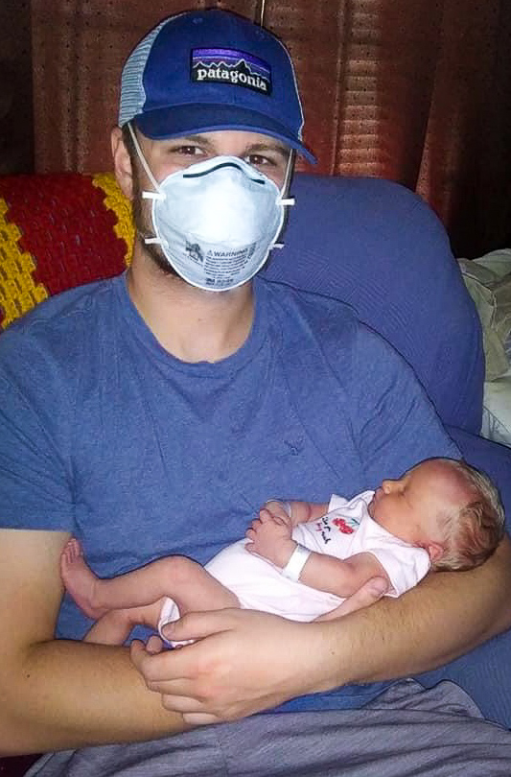
Masks were required when around Lilly for the first six weeks home

