COVID-19

X
Department of English, East Carolina University
ENGL 1100 Foundations of College Writing
Dr. Cheryl Dudasik-Wiggs
Fall 2020

COVID-19
It was March of 2020; It was my senior year in High School. All seemed well. I was playing my last season and fourth year of Wakefield’s women’s varsity soccer team. I was prom shopping with my mom to find the perfect dress for my senior year. I had already bought my graduation dress that I was supposed to walk across the stage with, already bought my senior night dress that I was supposed to accept my Latin Honors reward with, and already bought my graduation party dress to celebrate with my friends and family all of my accomplishments. It was all supposed to be so perfect, then covid-19 hit. A world pandemic. Right in the middle of my senior year.
Before I knew it, schools had closed, and the movie theater and restaurants closed their doors permanently. It all felt like a dream, but it was not. The news gave us hope, they said if everyone stayed home and social distanced, we would be back to normal in no time. Here we are seven months later, and the pandemic is still here, the movies are still closed, and schools are closed. I wanted to wake up from this nightmare, but it still lingered, like a dark cloud on a rainy day. I will never get to experience walking across the stage, looking for my parents to see the pride and happiness glistening in their eyes. I will never get to experience my soccer senior night and have all my accomplishments announced. I will never get to go to another prom. So many things I missed out on that I will forever wonder what it would have been like if this global pandemic never happened.
Although, there was a small hope that I would get to experience one thing, college. Before I knew it, March flew by and it was August. East Carolina University announced that students would be allowed on campus and classes would be held. I was never so happy, finally some normalcy in my life. I was so excited and could not wait. Finally, the day came, and I left for college. When I got there, it felt like a breath of fresh air. Everyone around me was just like me, anxious, nervous, excited and happy. We were all so relieved to finally have something that was not ruined by Covid-19. But, of course, there were some regulations. All my classes had to be social distanced, so I found myself in a desk in the corner of the class, so far away from anyone else. It was very depressing and disheartening. All I wanted was human contact since I had been quarantined in my home since March.
I just wanted to break free and have things go back to normal. College was defiantly an experience I will neve forget. Everyone walking around in masks, socially distancing themselves. Large groups were not allowed anywhere so it was awfully hard to find friends. Luckily, I had gone to college with four of my best friends, so that made things a little easier. But the lingering sensation of wanting to be free and wild was still there. I prayed that things would go back to normal and I could live life again. It felt like I was just existing and not truly living life. A lot of my classes were online, so I found myself sitting in my dorm room, staring into the abyss. Wondering how different things could have been if there was not a global pandemic.
These days, the media is so engrossed in fake news and wants to spread wide panic. So, it is always awfully hard to tell what is real and what is not. Is this virus even deadly? Are the number of deaths true? Do masks really work? Everything is all up in the air and no one truly has a real answer. The only thing I knew I could do was follow the CDC and watch the numbers and try to do my best to protect myself and my family. I was crushed when East Carolina University announced that we would have to go home. All I wanted was a somewhat normal college experience. It was very upsetting. Especially when I heard that yes, there may have been many cases but, many were asymptomatic and did not even know they had it. It made me terribly upset because it makes me question why are we being sent home if everyone is fine and its just cold like symptoms or none at all?
Once I arrived home from college, I had a period of adjustment. I had to put together my old room and figure out where to store all of my college stuff. I had to go and purchase a desk and chair so I could work in my room, since my mom and dad work at home and occupy the office in our house. I missed my friends so much but luckily; they live somewhat close to me, so we always try to meet and get together on the weekends. I missed the college atmosphere and freedom. I missed getting to do stuff on my own and do it at my own pace. When I got home, my mother really tried to take over and make more rules and curfews and it was very flustering because just a couple days ago I was free.
So far, learning online at home has not been my strong suit. It is very difficult for me to learn online, because I am a very hands on learner. My parents have talked to me about possibly transferring to a school that still has in person classes so I can get the proper education and really help myself be successful and learn. I did consider it. But, at the end of the day, I am a pirate and I always will be a pirate and there isn’t anywhere else I would rather be. I am very hopeful for this spring and I truly hope that East Carolina University has in person classes and everyone is allowed on campus.
In conclusion, this is most definitely an experience that will change me forever and truly impact my life. I will never forget when I was 18 years old and there was a global pandemic. The pandemic has taken a lot from me, but I know I must learn from these experiences and make myself a better person. Sometimes you have to have a lot of bad luck to eventually get some good luck.

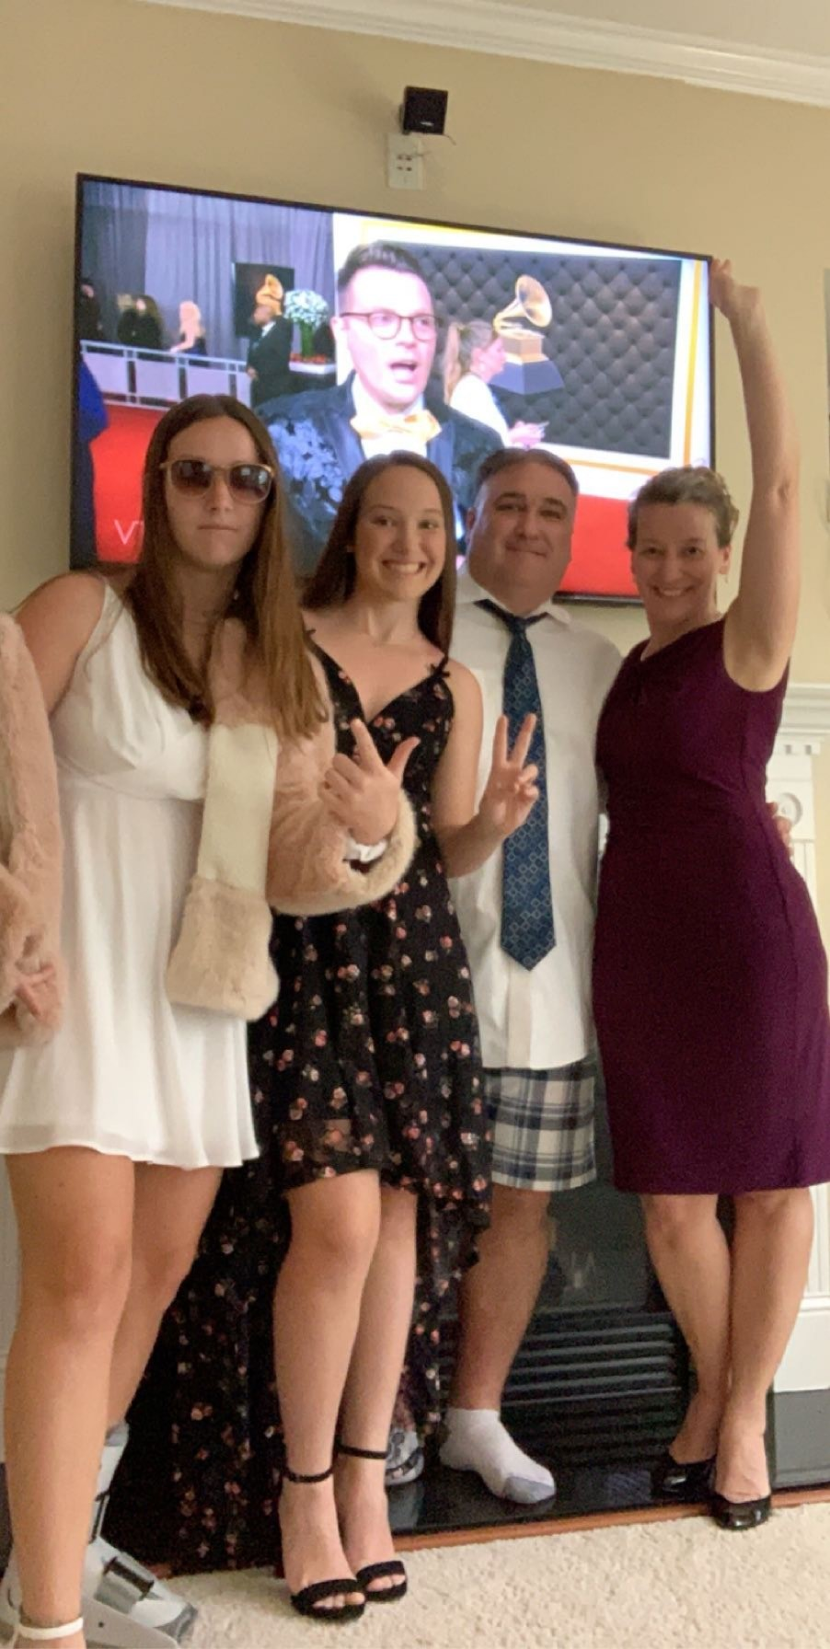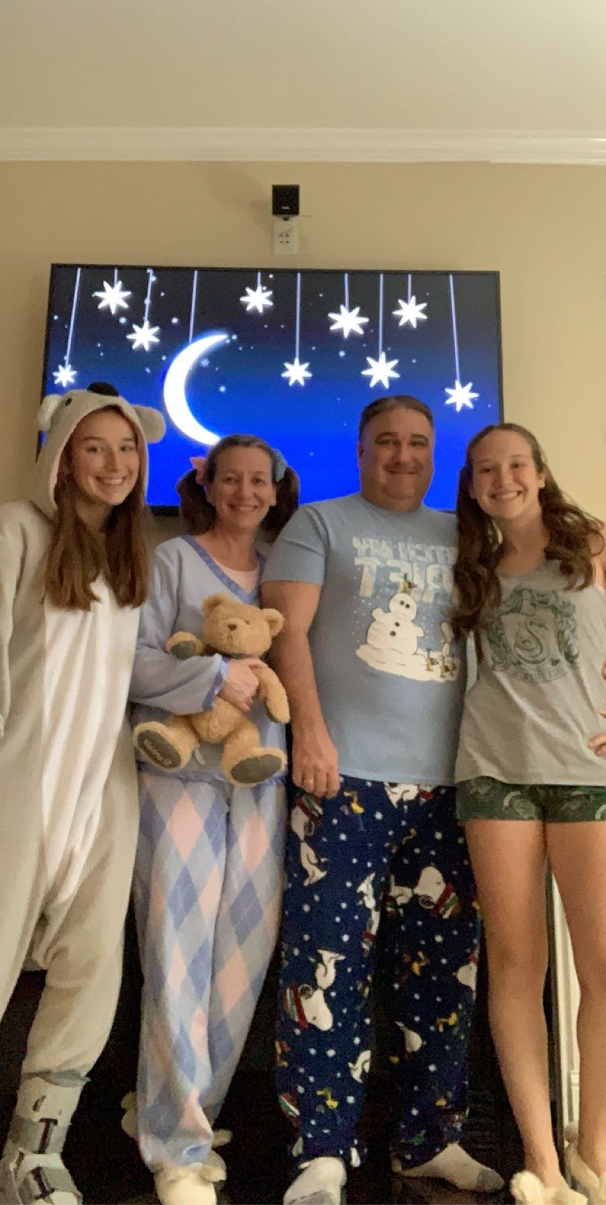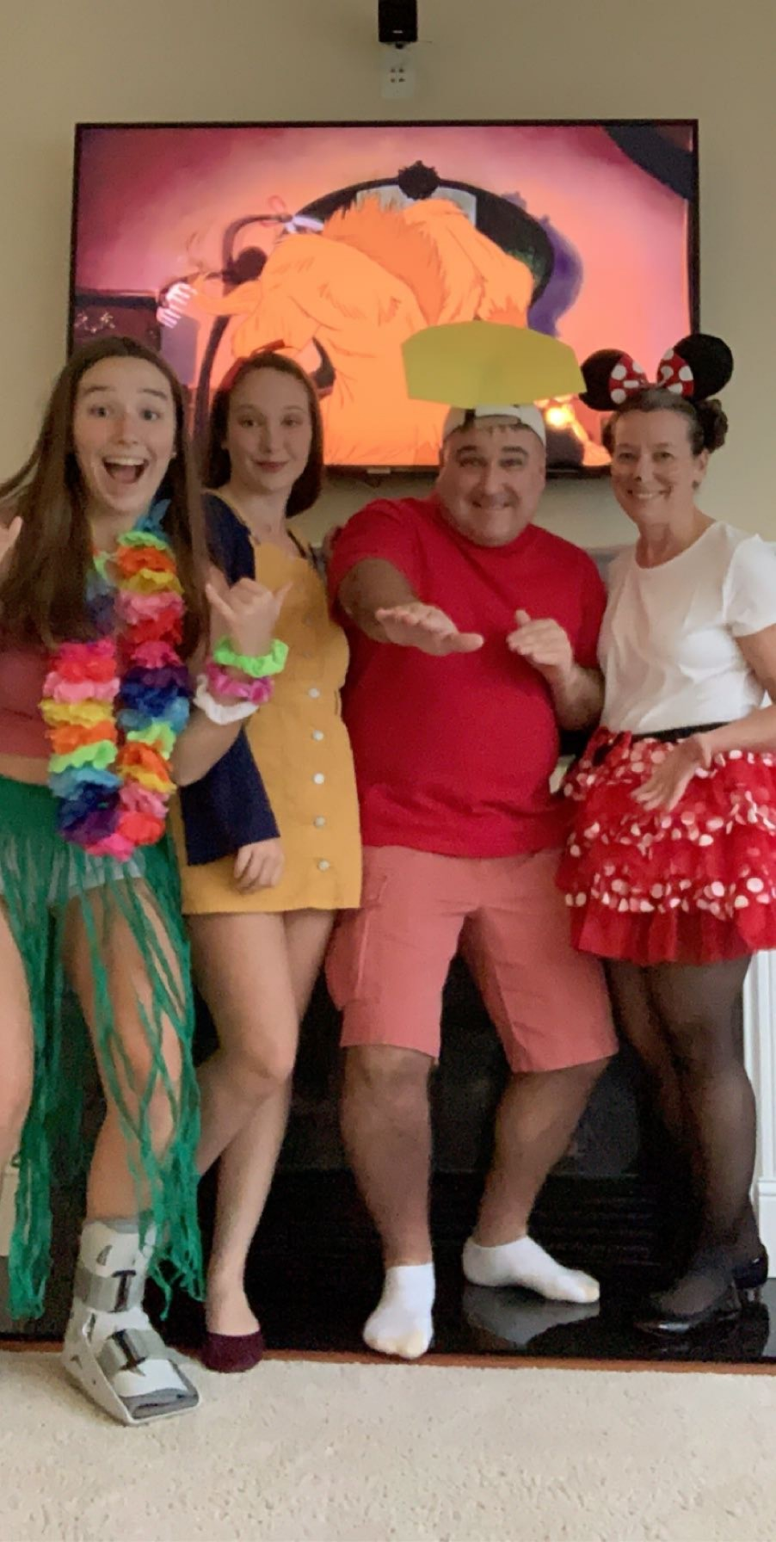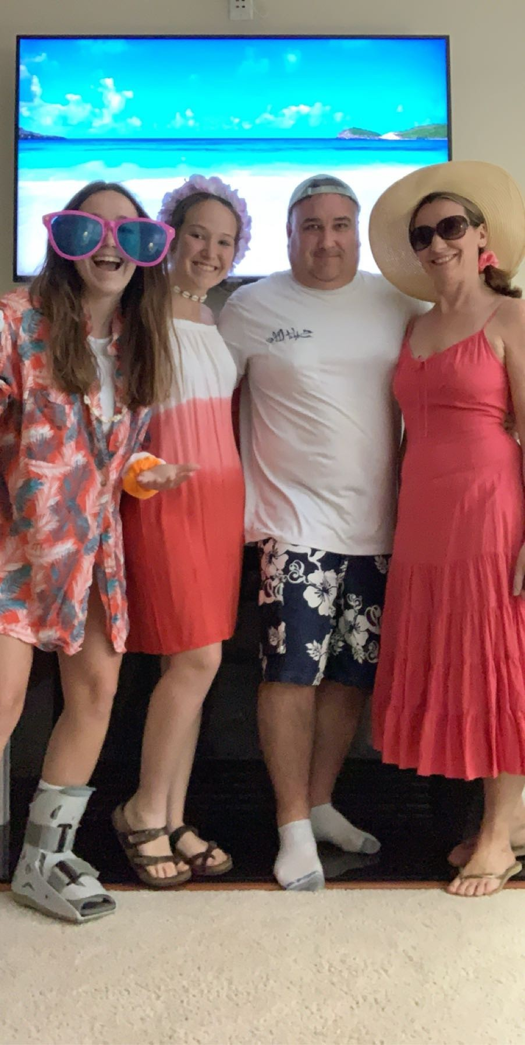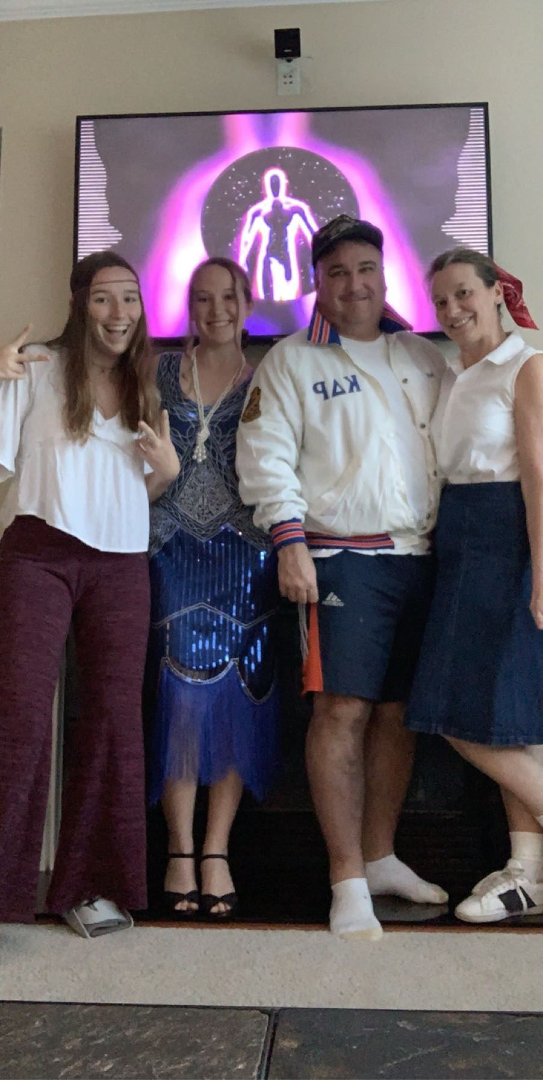
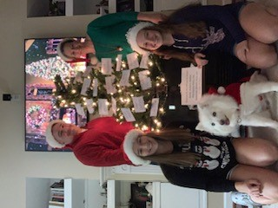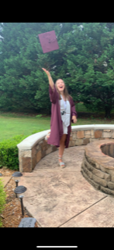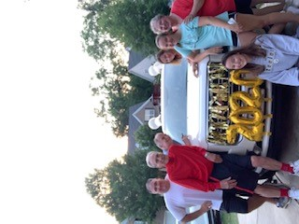
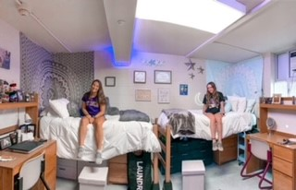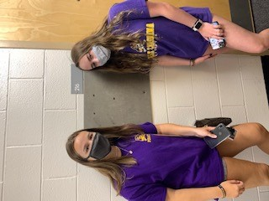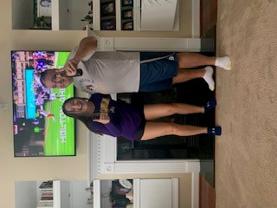
My family did six nights of themed dinners. Oscar Night, Pajama Night, Disney Night, Hawaiian Night, pajama night, and holiday night with a tree to thank all of our doctors and nurses. I then graduated from Wakefield High School and decorated the car for our drive through graduation. I then moved into ECU with my roommate. I watched the first ECU football game with my dad.

