1. 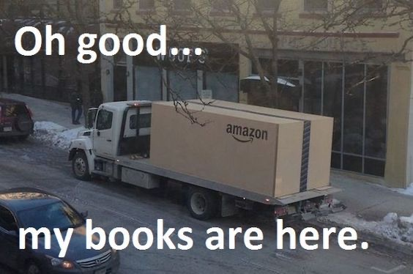
2. A delivery truck has pulled up to an apartment building to drop off the package. The box says Amazon on the side and takes up the whole bed of the truck. The text on the image says, “Oh good…my books are here.”
3. I chose this meme because between me and my mom we had books from Amazon coming to the house often. During this time all we did was read, seeing as there wasn’t anything else we could go and do, eventually we started ordering books because we were finding more we were interested in but didn’t own. There was actually a moment when the two of us and a few neighbors that were also big readers started to have a competition on how many books we could read during this time, I won.