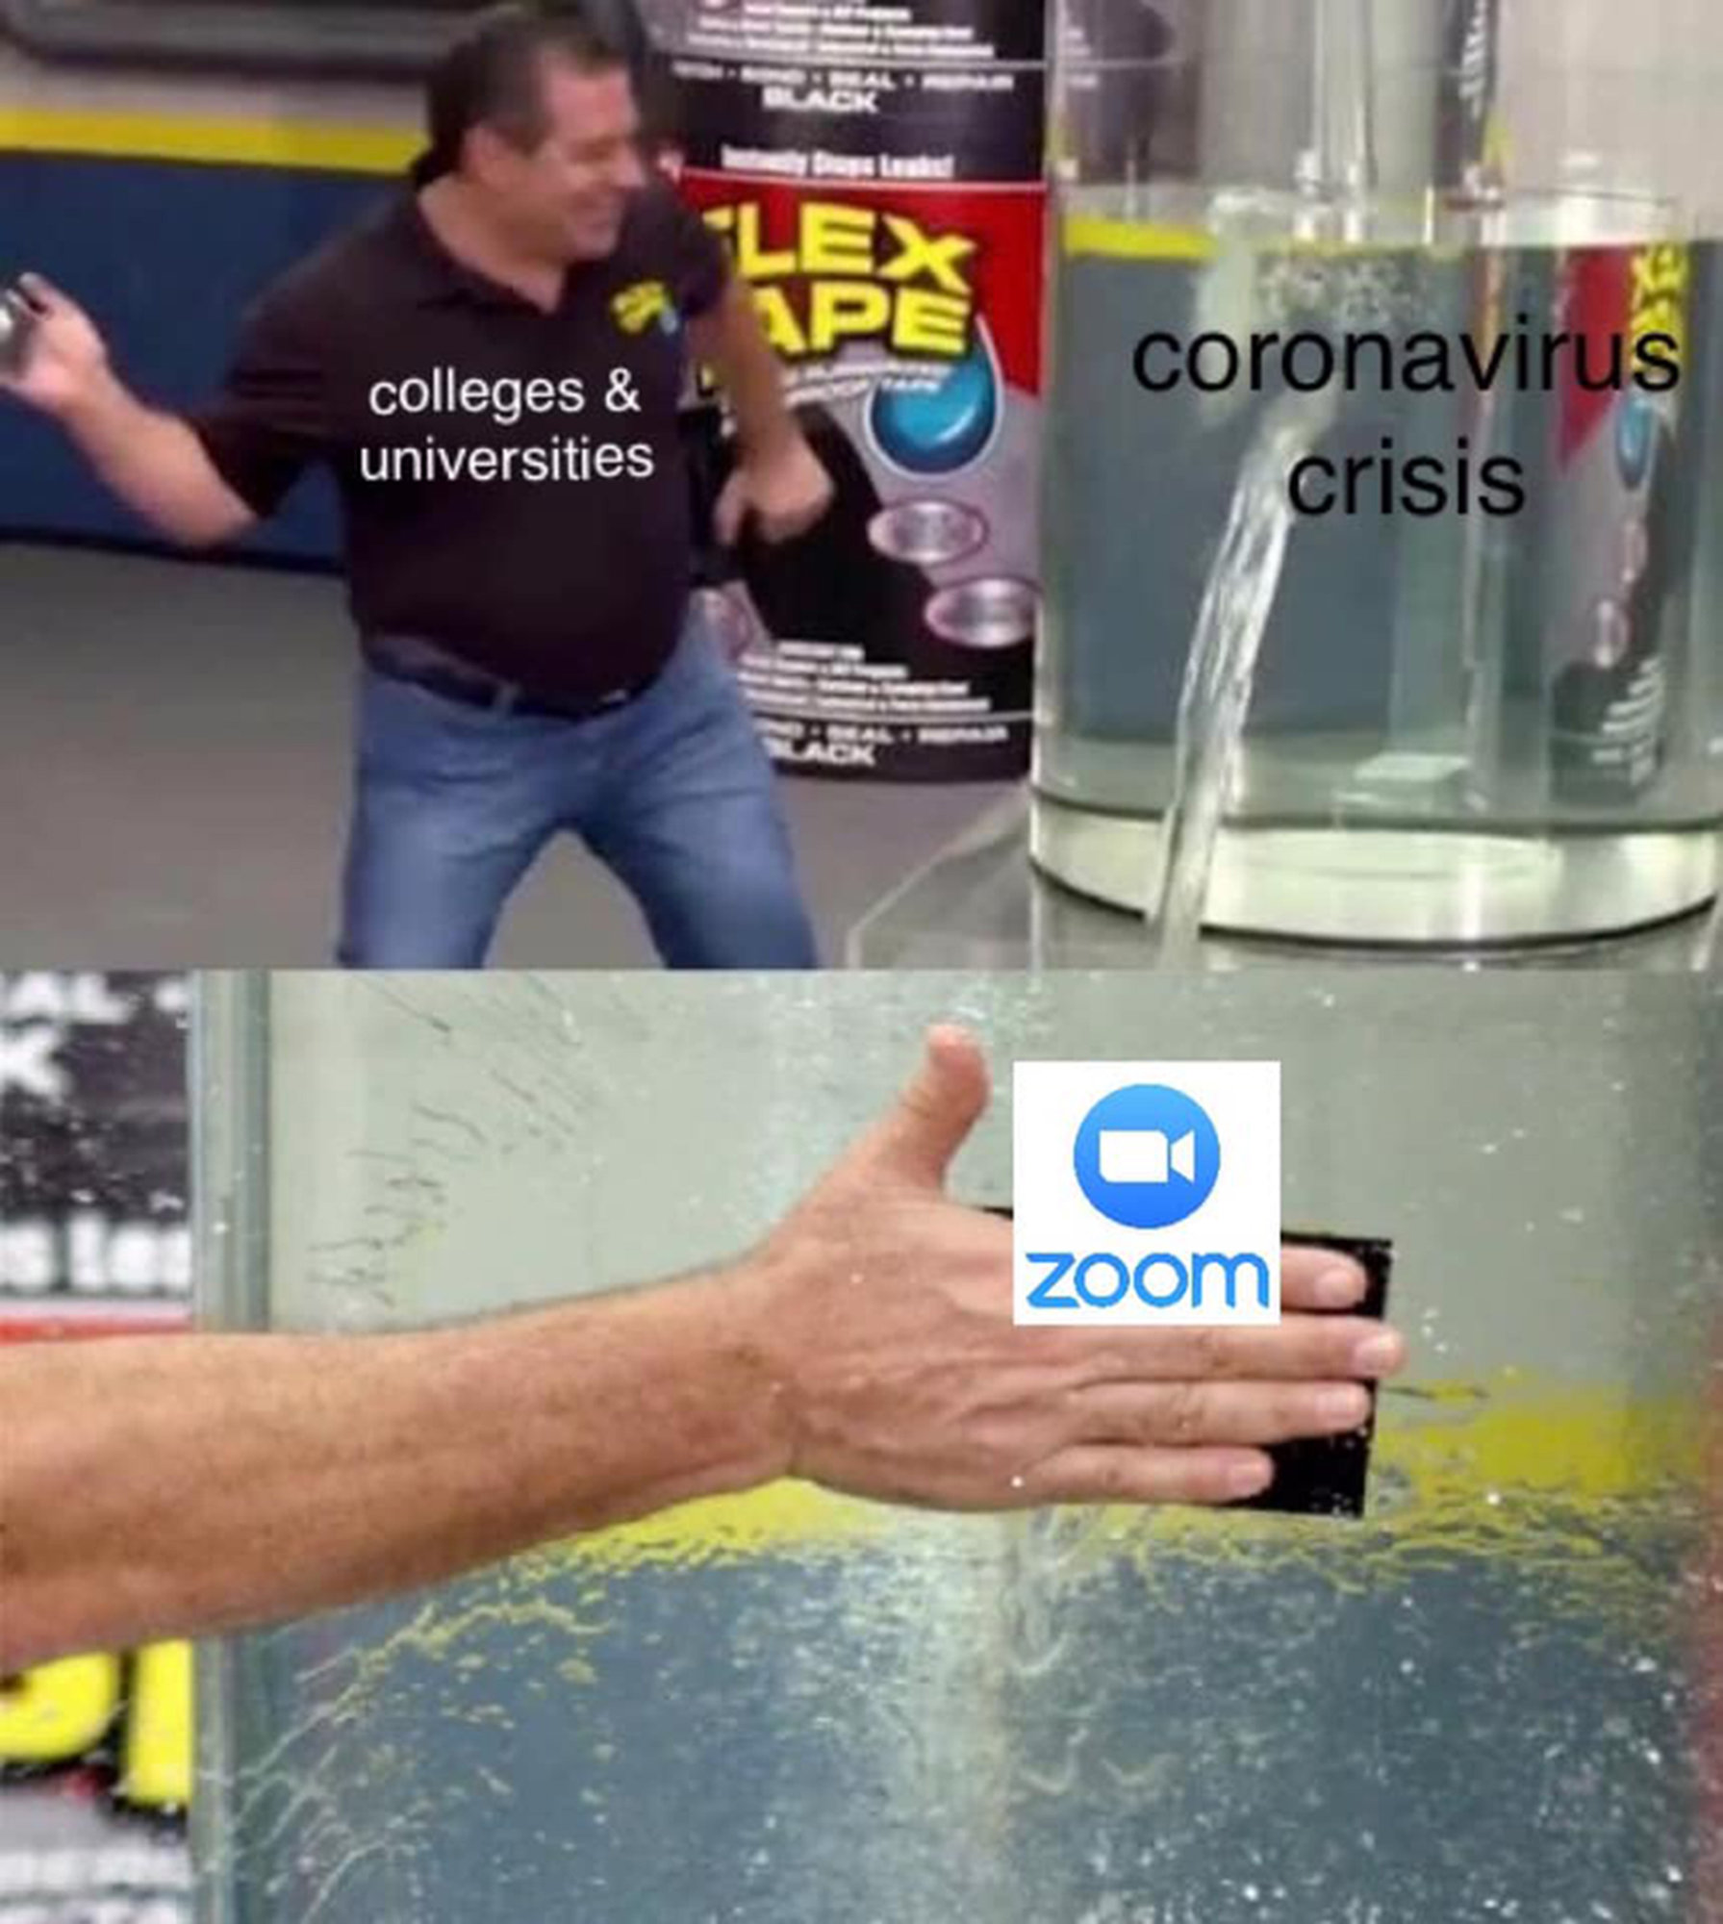

Image description: The top image pictures a guy with the words “colleges and universities” on his front, putting tape over a hole in the side of a vat of water with the words “coronavirus crisis” in front of the leak. The bottom image shows an up-close look at the same guy’s hand placing the tape with the Zoom logo in front, over the hole in the vat of water.

Reflection

As a nation, we were all so excited for the 2020 new year to bring good things and happiness for everyone, but the sad reality of it was that 2020 brought a full pandemic with it that would hold the world hostage for two full years. I chose this specific meme because I think it really lays out my toughest experience with the coronavirus pandemic, which was school putting classes online and reducing my ability to socialize with kids my own age. I think it also symbolizes how my generation was able to cope with the pandemic. A good amount of Generation Z was forced to stay at home with tough family lives, so we had to find an outlet to help us get through the almost two years at home with only family to interact with. Personally, I know was keeping myself afloat with mostly humor during the time I was stuck at home because once I stopped making jokes about the pandemic we were experiencing, I would have gone straight into a panic.

Once the pandemic hit full force, forcing people to stay home and self-quarantine is when learning went completely online. When learning was switched to online teaching, I was in my senior year of high school. I was doing a dual enrollment program at a community college. At the time, I had been enjoying the two semesters I had been there, but my stepdad had gotten a new job, so we had to move. Before the pandemic became a big issue, I had been excited to make new friends and explore a new community college, but due to Covid-19, those plans were trashed. As a senior in high school and moving to a new town, the first thing I wanted to do was make friends. With school being completely online and Zoom meetings being the only form of social interaction besides my parents, I was short in the new friend's department. At first, I thought some time alone at home would be fun until I quickly realized there was no one my age to hang with, so I got to spend the entire summer and senior year stuck at home with my parents.

As I mentioned in the above paragraph, I was stuck in a house with my stepdad and mom for a long period of time. Until the two-year-long coronavirus pandemic, I never truly realized how bad being home was for my mental health. Being at home for that long brought up a lot of repressed trauma and depression that had been pent up for so long that I could not take it anymore. Every day I was trying to find something, anything that could get me out of the house or just busy enough that I did not have to interact much with my parents. The hardest part was keeping my distance because both my parents, especially my mom, saw the quarantine as a chance for “family bonding,” which I did not want to participate in. Quarantine made me focus heavily on my mental health because, during those two years, I realized I had been neglecting my mental health. While my mental health did suffer greatly during the worldwide pandemic, I came out on the other side with a better understanding of what I needed from myself and other people, which I am grateful for now that I am looking back.