Meme Assignment

Meme:

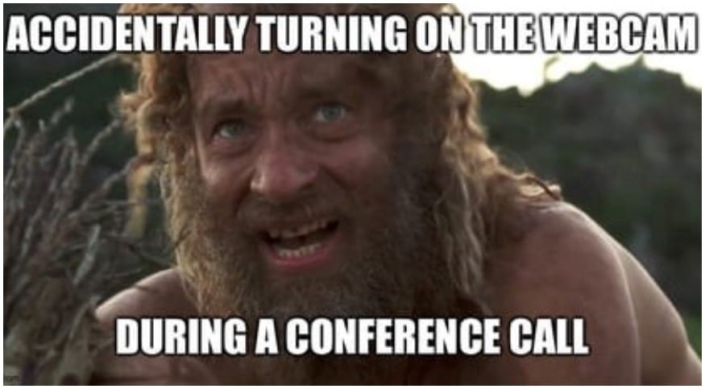

Alt Text: This image shows a hairy dirty man looking up while half naked. The text reads: “Accidentally turning on the webcam during a conference call”.

Reflection:

I chose this meme because during covid everything was moved to online. Internships, meetings, some family gatherings, school, etc. were all moved online. Being cooped in the house for two years during the pandemic, by the end of it, I’d day I was over it and looked like the picture. this meme means that during covid I would never get ready for my meetings or school and just do my work looking essentially like a ‘bum’ in my opinion. I wouldn’t say it explains my experience with covid, but this meme has a grasp on what most daily life was like during covid for me. I was always in meetings and always underdressed during those conferences.

Covid was an experience that I didn’t care too much about. I don’t think anyone really ‘cared’ about covid, but I wasn’t worried about the pandemic as much as the population. The pandemic really hurt a lot of businesses. The ones that couldn’t work remotely were constantly missing employees and going out of business. The pandemic did a lot of damage mentally to the public because we are constantly being kept in a box with your family.

Researchers in the future won’t understand but the individuals reading now will understand that being in lock down in a box (house) and can’t leave the home without being frightened that if you have covid its over for you. The media made the reaction worse on the public. I think the media is the leading cause on why I stayed in the house more than I went out which led me to look like forest gump in that meme.