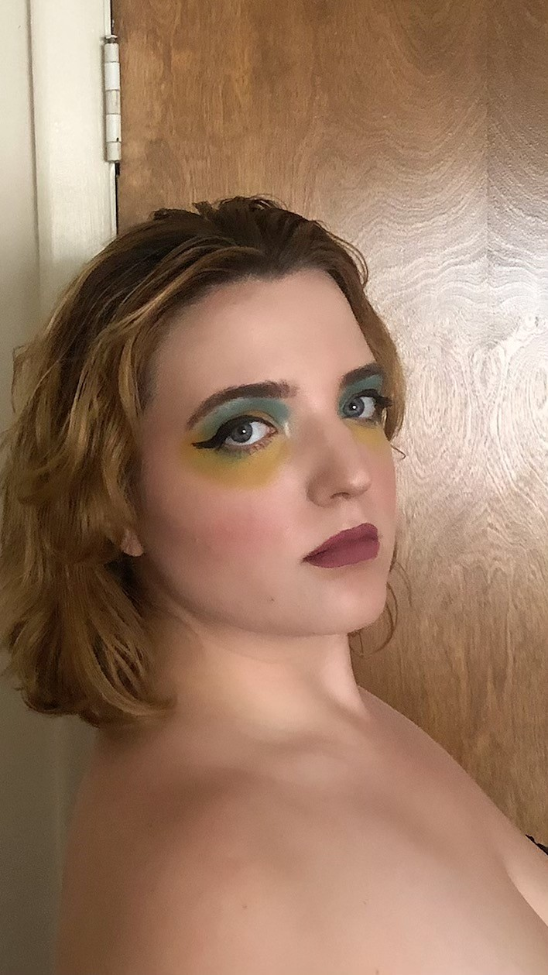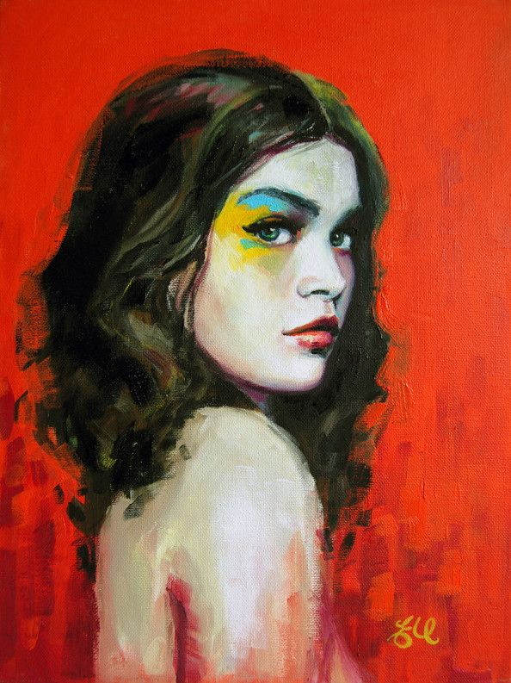

Hello! My name is Celine Greene and I am senior at ECU studying Theater for Youth in the School of Theater and Dance. I am a very competitive person and have most recently started my journey in weightlifting and I also am training for a half marathon. In my spare time I like to play guitar, watch movies, bake recipes from the woman herself, Mary Berry, and do puzzles. I got involved in theater in high school and decided that that's what I was meant to do in college, although I prefer film to musicals. My favorite playwright is Tracy Letts and my favorite director is Greta Gerwig. I don't know a lot about visual arts, but I'm very excited to learn in hopes to become more worldly.

The painting I chose to recreate is one by Emma Uber, a contemporary Australian artist. My process for this was to do my makeup in the same way the artist has painted the woman and then have my boyfriend take the picture. I then edited a little to get the angles right. Thankfully, I bought an eyeshadow palette a couple years ago that had very similar colors to the ones in the painting and a person here who could take my picture.

The artist's name, as stated in the previous paragraph, is Emma Uber. She lives in Adelaide, Australia. In her work she primarily uses oil paints and pastels to create her works and is inspired by comics. The painting is entitled "Pyro" and was created in 2011. I chose this painting because I loved the vibrant colors. Aesthetically speaking, I am partial to neutrals in a space with a colorful focal point and I can picture myself hanging this particular piece on a wall. I also really like the look on the girl's face. It is slightly mischievous, yet soft.

I actually really enjoyed this project. It was a great way to break up my otherwise monotonous day. In terms of creativity, it was definitely up there. However, being a theater major, I already do quite a bit of creative things throughout the week, this was different.