Courtney Gentry

Professor Kitta

ENGL3570.002 American Folklore

22 April 2022

Meme Assignment #3

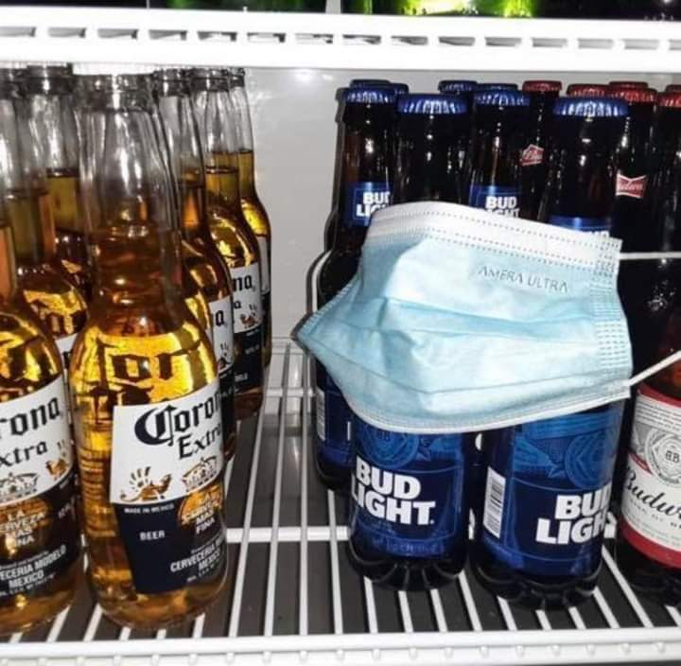

The meme that I chose is a picture of the inside of a refrigerator (possibly at a grocery store or convenience store) where beer is sold. There are several bottles of Corona Extra turned as if they are facing a group of bottles of Bud Light beer. There is a disposable face mask surrounding several of the bottles of Bud Light. There are no captions for this meme.

During the coronavirus pandemic, along with social distancing and quarantining, the most widely recommended way to prevent contracting and spreading the coronavirus was for everyone to wear face masks. These face masks could be disposable, made of cloth, or N95 masks that were needed in medical facilities. Most schools and places of business required that everyone inside had to wear a face mask at all times. There were even requirements for events that occurred outdoors and people were required to wear masks. I understood the restrictions and I understood why these requirements were in place. It was in order to control the spread of the infection and to prevent more people from becoming sick and dying. However, it seems that there have been quite a few people who took mask wearing to an extreme.

It seems that everyone became paranoid about catching the coronavirus. I understand completely because I became sick from it and it was horrible. I also work during the summers at a nursing home and ⅓ of their residents died during the pandemic. But this meme seemed to show how extreme the obsession with wearing masks had become. The meme shows that the Bud Light beer is “afraid” of catching the coronavirus from the Corona Extra beer (evidently because of the name, one would assume that it is associated with the coronavirus). So the Bud Light beer bottles are covering themselves with a mask to protect themselves. I understood the seriousness of the pandemic, but I enjoyed seeing memes that would bring some humor out of a serious situation.

The ridiculousness of this meme makes me laugh, which I think is something that all of us needed at times during the pandemic. There was always so much sadness in the news and everywhere that you turned during the pandemic, and it made looking at something silly like this even more enjoyable. I honestly think that this kind of meme whenever I see someone driving in a car by themselves with a mask on. That seems ridiculous to me and I don’t understand the purpose of wearing a mask when you are alone in your car. Funny jokes about the pandemic

weren’t created to make fun of something serious, in my opinion, they were created to give people a chance to laugh and sometimes laughter is the best medicine.