Meme Assignment – Hailey Dinner

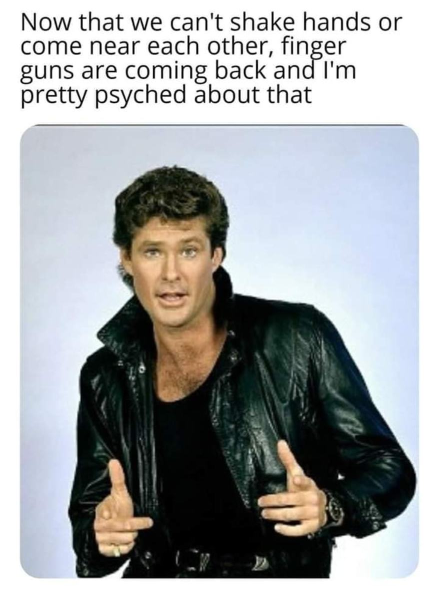

“Now that we can’t shake hands or come near each other, finger guns are coming back and I’m pretty psyched about that.” Man is holding up finger guns.

I chose this meme among many other COVID-19 memes because I could relate to it on a more personally level. During the pandemic, more so at the beginning, most people were learning how to interact with each other in a new way. People were scared of each other in fear of contracting the virus and in fear of violating their personal space. Because of this, it became a common practice to ask people if they were comfortable with any kind of contact like handshakes, high-fives, and fist bumps. My first memory of this interaction was at church in the early months of COVID mid 2020. Most churches engage in some kind of physical contact before and after a service. This is the time to catch up with friends and family, so it is not uncommon to give hugs and handshakes to people. Since COVID had changed many people’s comfort level to do these things my church implemented a “sticker system”. Upon arriving, people would choose between three stickers that read “I like fist bumps”, “I like handshakes”, or “I’m a hugger”. By doing this, everyone was able to express how they preferred to be greeted during this time. None of the stickers were either right or wrong, but you could almost feel the social divide these things created. For example, people who were still okay with forms of close contact like hugging were looked down upon because they weren’t doing their job to help “slow the spread”.

My family were people who were comfortable with close contact throughout the pandemic, especially, my mom and I. Both of us are extremely expressive people who like to talk with our hands and do things like put a hand on someone’s shoulder when we are laughing in a conversation. Relearning how to communicate with people during and after COVID became the biggest obstacle for us. When I was able to go back to in-person classes, I went through an awkward phase where I felt like I didn’t know how to be in social situations anymore. I constantly was thinking things like, “Is it appropriate to pick up someone’s pencil after they’ve dropped it?” or “Should I leave the room to cough?”. It was astonishing the way the pandemic had driven the establishment of a new type of informal social control. While adapting to new behaviors was a challenge at first, it benefitted me too. I had to learn how to ‘read the room’ and determine the best way to communicate with someone depending on how they felt. For example, after masks became optional at schools, some people were still opting to wear them. If I ever needed to speak with a student or professor who was wearing one, I understood that it was a common courtesy to put a mask on before speaking with them one on one. In other situations, I would learn how to read a person’s body language to determine if they would be comfortable with close contact. Understanding how to do these things helped me better understand how to adapt and have better relationships with people since I could create a more neutral environment. Now, I feel as if I have been able to further develop my professional skills as well since I am able to effectively communicate with any type of person. While physical contact as a form of communication has decreased, the ability to understand social cues have improved, in my opinion.