Covid-19 Meme Reflection

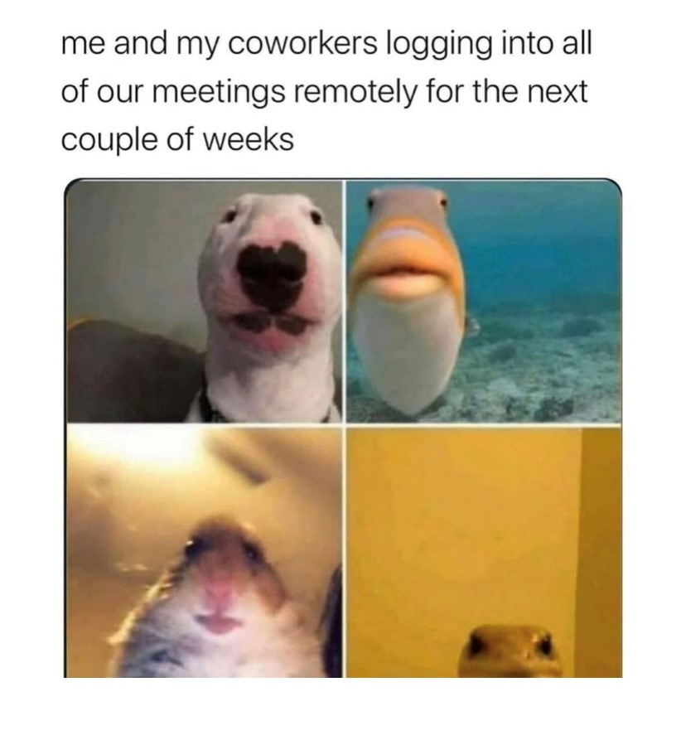

A four-grid picture of different animals staring “at you” from the invisible camera. From top to bottom, left to right, it’s a white dog, yellowish fish, a hamster, and a lizard. The text says, “me and my coworkers logging into all our meetings remotely for the next couple of weeks.”

I chose this meme because I could relate to this meme a lot, especially during the beginning of the pandemic. Because of rise of Covid-19 and increase of cases, we had to transition to online delivery to help slow the spread of covid. If you did have the virus, you were urged to quarantine at home until you got better. People at first weren’t taking the virus seriously (some still aren’t) and it made the virus spread like wildfire. People were and are dying daily because they contracted the virus, and it made this people finally realize the severity of what was going on. Things changed in everyday life because of the Covid-19 pandemic. We were asked to wear masks in public settings, not congregate in big groups, and social distance to help stop the spread the virus. Ways I had to keep myself occupied during the pandemic included binge watching a lot of tv shows and reading a ton of books. I read 50 books last year during quarantine, if that tells you how much time I had because I never really went anywhere. And those books were long, with some being up to 1,000 pages. I had too much time on my hands. The pandemic has affected everyone in a myriad of ways, and effected people’s mental and emotional well-being. A way a lot of people coped with the pandemic was Tiktok. You could browse funny videos and you could relate to them because they were going through the same thing you were.

I remember we had just transitioned to online meetings for class when we had to go remote my freshman year here at ECU. Little did we know that the would be the norm for a while after that semester. We were online for my sophomore year here, and to this day I’ve still have online delivery classes and it’s February of 2022, when we started online delivery in late 2019. I used to hate going to class online like that, for some reason it was awkward to me doing it online video than it was to just go to class in real life. I chose this meme because as soon as I saw this, it made me laugh. Our society would understand this meme and agree. I found it hilarious because this is almost exactly how it is when we have to do class online. Nobody wanted to turn their camera on, and when we do its all of us just staring into the camera like the animals are in the meme. This meme accurately reflects how it is to be in a zoom meeting and it’s hilarious to see it portrayed by these animals from completely different memes, put into one that still makes perfect sense. I find this meme scarily accurate because all of the animals have a blank stare on their face which is exactly how everyone on a zoom meeting would be, especially if it was early in the morning. If you showed any Gen-Z this meme, we would all know how this experience was. This meme is a great representation of what we had to endure during the beginning of the pandemic and how it is indefinitely.