MEME Assignment

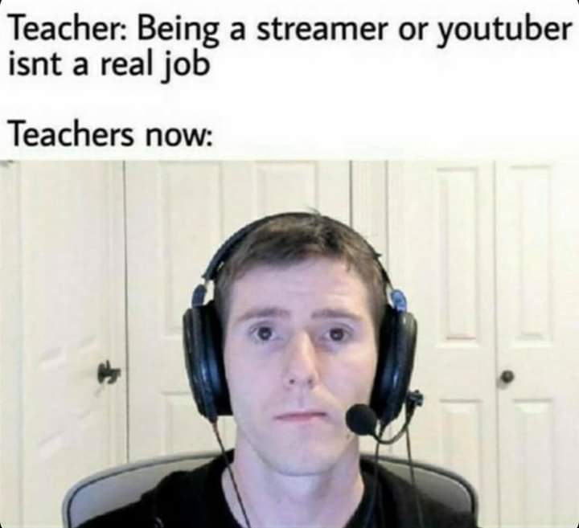

Description:

Teacher: Being a streamer or YouTuber isn’t a real job.

Teachers now:

Youtuber Linus Sebastian from Linus Tech Tips stares at you with a blank expression while wearing a headset with a microphone, sitting on his chair ready to stream/record a video.

REFLECTION

I choose this meme because it describes how student and teacher lives were affected by the Covid-19 pandemic lockdown that lasted almost two and a half years. COVID-19 was an airborne virus that originated in the city of Wuhan, China in late 2019. This virus was an atypical pneumonia-like virus that was not treatable with common medicine. The virus quickly spread through China in early 2020 as the government and the CDC were not able to identify the cause of the spread. On January 23, 2020, the Chinese government imposed a lockdown on the entire country to control the spread of the virus, but cases in other counties had already started appearing. In March 2020, the World health organization declared Covid-19 to be a global pandemic, and by the end of the month, most educational institutions were closed and were due to open after two weeks.

By April 2020 the number of covid cases around the world had exponentially increased and many and the United States imposed a nationwide lockdown. At the start of the lockdown, many cities had imposed curfews, and many businesses would be closed early. This was a good rest period for most people as they did not have to go to work and most students had time off from school. The CDC and WHO also instructed people to social distance, which meant wearing a mask and maintaining a minimum of six feet from other individuals. Schools and businesses could only stay closed for a brief period, so most institutes and businesses transitioned to Work/Learn online.

At the start of the pandemic, I was a senior in High School in my last semester with only 3 months left until I graduated. The start of the pandemic was super fun for me as I did not have to wake up at 6 am in the morning to get ready for school and there was no homework. But this blissful period of no school only lasted for three weeks, school resumed in April 2020, and most of my teachers transitioned to online lectures and homework. The meme explains my experience because some of these teachers had previously argued to students to not pursue a career on YouTube or other streaming services and now their entire job depended on streaming their lectures to their students through these online streaming services. The transition to online classes lasted through my freshman year of college. This was a perk as it helped me do my work on my own time and pace, but this also deprived me of socialization with my peers. The decrease in social contact for almost one and a half years had a great mental impact on me and my friends.

With no in-person classes, making friends as a freshman in college was an excruciating experience. The only people I had social contact with other than my parent were my roommates and with the university, strict no-visitor policies the dorms almost felt like our own personal jail cells. When the lockdown ended and in-person classes resumed it felt like the campus had gained its life back, and I finally felt like I was in college. It was a hard journey through all the challenges, but we finally made it to everything going back to normal.