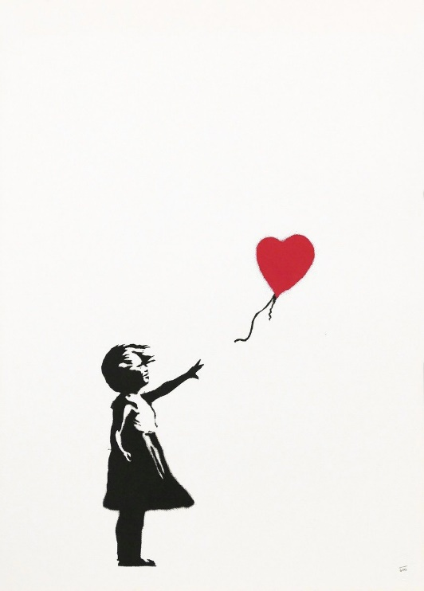 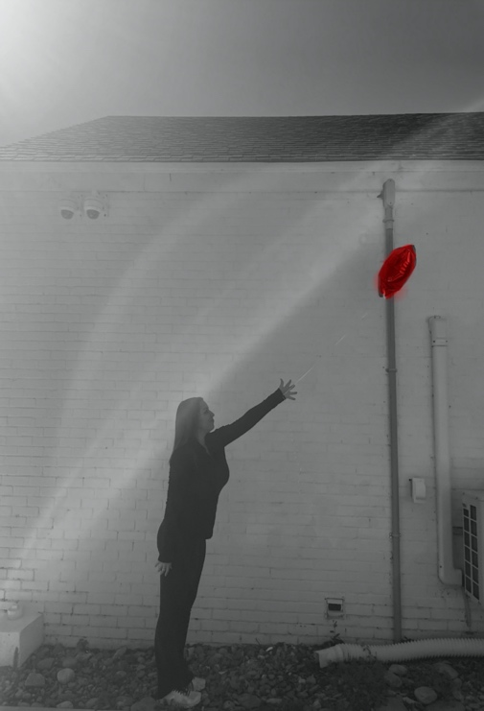

I am a nursing major at East Carolina University. Some of my interests include traveling, going on long walks, and just hanging out with my friends and family. Growing up I really enjoyed drawing and painting. I used to be really good at both, but then I stopped so I don’t think I’m as artistic as I used to be.

First, I went to the grocery store to get a red balloon for the picture. All of the materials required to recreate this photo were very simple to obtain. I made sure to wear all black and stand in front of an all-white background to really capture every aspect of the art piece. As for capturing the picture, my friend Tayelor took it for me.

Banksy is the name of the artist who created Girl with Balloon. The art piece was created in 2002 and released as a print around 2004/2005. I chose this piece of art because I found the meaning to be very interesting and unique. The photo to me feels as if it was a self-portrait because it represents loss of innocence as you begin to enter adulthood, similar to entering college and no longer living under my parents roof.

I found this project really creative because I’ve never done a project that allows a lot of creative freedom.

This project was really fun to do because during quarantine there isn’t much to do. It provides an outlet for creativity and laughter in a time where life is a little depressing.