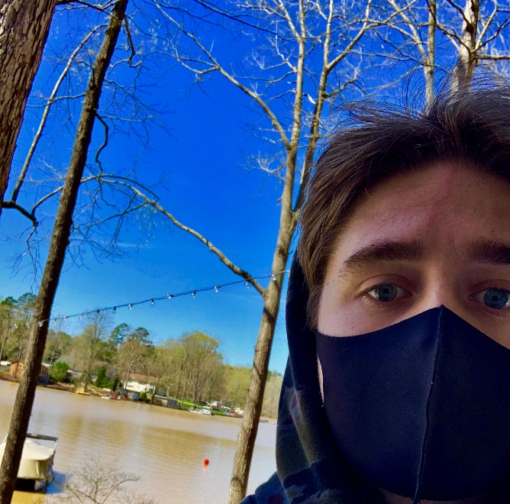

1. Hi! I am a sophomore at ECU, majoring in Construction Management. In school, I mostly work in Commercial Construction. I am interested in history, traveling, and all different types of music. I enjoy art, but I haven't taken many courses on it yet but I am interested in learning more in how art can expand my mind within the construction field.

2. For this project I took a selfie with a normal protective mask at my lake house at High Rock Lake in Lexington, North Carolina. I used my phone and a mask as my materials and I took a selfie-styled photo in order to get the lake in the background so others could grasp the beauty of nature in the Spring time as flowers are beginning to bloom again and more wildlife is coming out.

3. Since Covid is still going on, I wear a mask like this one on a daily basis whenever I leave my home. It is actually a cool breeze mask, making it easier to wear for long periods of time. Some covid masks make my face hot and itchy or make it harder to breathe, but this one does not. It even allows me to be able to smell and enjoy the fresh spring air.

4. I took this photo in the afternoon time when the sun was the brightest in order to fully capture the beauty of the nature behind me. The lake is my favorite place to be as it is so relaxing to me. The natural sunlight brings out the blue sky, the glass plants, and the smooth, calm water behind me. I felt that this project was perfect during the Pandemic due to the fact that masks have become such a necessity to the world around us and this project allows us to make something beautiful out of it.