American Folklore
COVID19 Meme Assignment
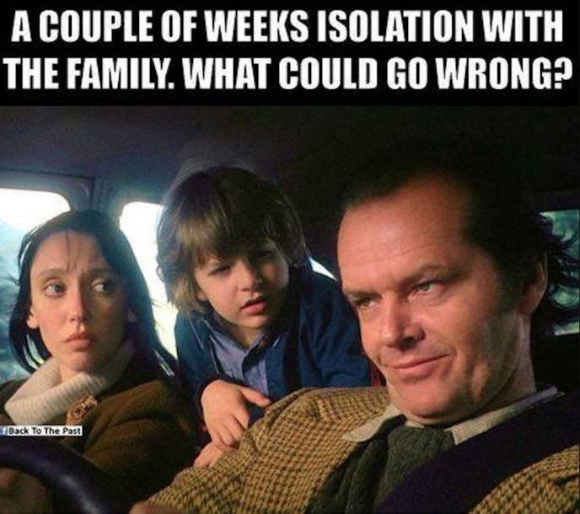
The meme above is a screenshot from the movie “The Shining,” released in theaters in 1980. It is a film adaptation of Stephen King’s novel, which shares the same name. It features a family of three going to a remote hotel that is not what it seems. Without spoiling the film, horrifying/psychological things happen, and the father shown in the photo goes insane and starts hunting down his wife and child. As you can see in the picture, the meme’s caption ends with “What could go wrong?” when you know what happens in the film, it hits you that the man there will try hunting down his own family after going insane.
I chose this meme because of its dark humor and psychological understanding of the human mind. Of course, I don’t expect the creator of this meme (whoever that is) to have thought that much about it. They probably have “The Shining:” as their favorite movie. or just recently watched it and thought, “hey, going insane in a remote hotel due to being stuck inside it, alongside the rampant isolation. That sounds familiar.” Isolation, even for short periods, can make people more susceptible to mental psychosis; it’s not just the person seeing or hearing things that aren’t there. Their entire way of thinking becomes warped. This happens to the father in the image shown above, who, influenced by his deteriorating mind, goes insane and hunts down his family with an axe. This makes the entire caption of the meme humorous in a dark way. It’s asking the viewer, “What can go wrong with being isolated from my family?” We know it can go very wrong when you have seen the film or read the description above.
Isolation was a rampant problem during the COVID-19 pandemic. I was used to it as I am an indoor person who only goes outside for groceries or my job (which was considered essential). Most people, however, are different. They had more active social lives they had to abandon to stay inside. I continued with life as usual, as my job as a stock clerk at a grocery store was considered essential, and my hobbies related to the indoors rather than outside. Listening to other people who were more extroverted was how I learned how much the pandemic affected people. Some couldn’t even see their dying relatives in the hospital in their final moments. Others were slightly panicking, which I believe is due to their isolation and fear of dying from COVID-19. People with careers struggled to get by as they weren’t considered “essential” and had their jobs frozen. People who had friends to go out with daily were now isolated in their homes, wondering when they could talk to them face-to-face. I remember seeing many people with healthy minds detonate due to loneliness. People underestimate how much loneliness affects both physical and mental health. Some can even die from it. Humans are social creatures. After all, we are meant to be around others.

