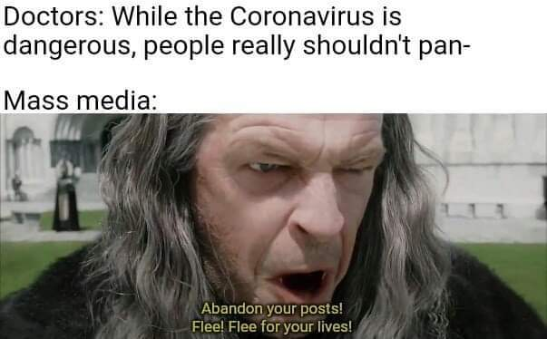

Old cranky grey haired man says in a deep raspy voice “abandon your posts! Flee! Flee for your lives!”

I chose this meme because it spoke out to me about the correlation between the coronavirus and the mass media. The meme represents how the mass media reacted poorly to the pandemic. The mass media didn’t overreact, however, they raised panic throughout the world. Many media channels spread misinformation and people really didn’t know what to believe or who to believe in. To me this shows how much power and control the mass media has on viewers. I remember during the height of the pandemic, that people were turning to drinking methanol or alcohol-based cleaning products like Clorox because of the spread of misinformation.

My experience with the pandemic was a weird and scary one. Luckily my friends and family were safe during the pandemic. The pandemic closed the world down. I never got a prom in high school and had 4 at bats in high school before everything was canceled. High school was over; however, college was right around the corner and I was gearing up to play baseball at a D2 school in Charlotte. The pandemic ruined everything in college. It didn’t even feal like baseball was the top priority. The first week at in college I got covid and they sent me to a hotel to quarantine and brought me food like I was a prisoner. As soon as I was out of quarantine my dorm goes down with covid and I’m back in quarantine for another 2 weeks. After quarantine I was playing well, lifting, gaining weight, and gaining velocity on the mound, however another setback was coming up. During the middle of the season I deiced to get the vaccine and the next morning I woke up with the side of my face drooping. I went to the ER and I had a reaction to the vaccine and developed bells palsy. Luckily I only had symptoms for a month and it went away quickly. Playing college baseball was my top priority however with the pandemic it did not feel like college baseball. I ended up getting hurt at the end of the season and transferred back home where I decided to get into coaching so everything worked out in the end.

Covid is a dangerous pandemic that effects peoples lives daily. The mass media raising alarm about the pandemic towards viewers does not help stress levels. Raising those stress levels puts pressure on people to stay safe however, it can take time from something that intrigues that person. My story relates to the meme because of all the stress that covid has put onto the world and how the mass media has manipulated scientists words into panic.