Meme Assignment
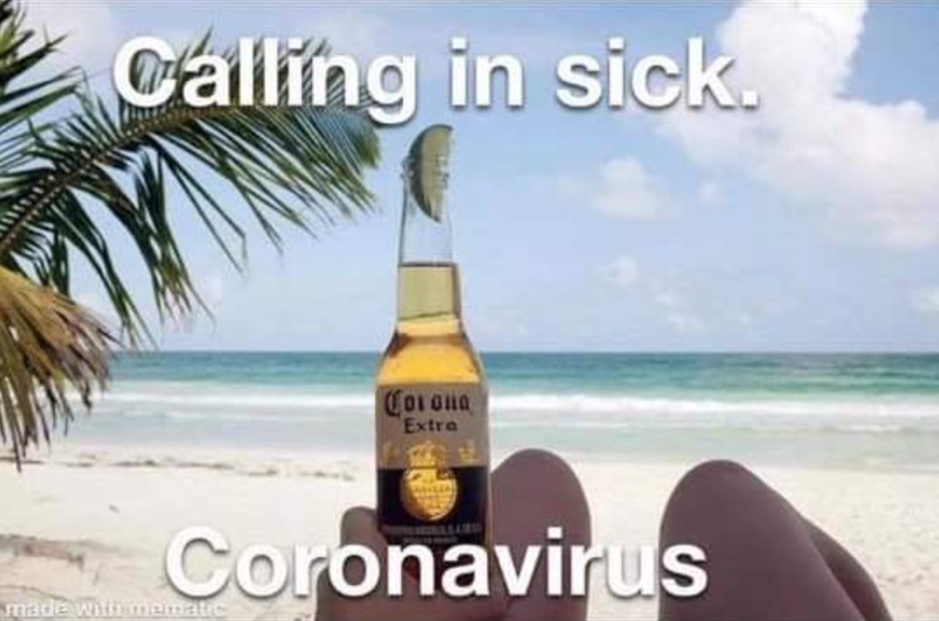
Description
This meme is a picture of a white sandy beach with light blue water. It appears to be a nice sunny day with blue skies and some fluffy clouds. To the left of the picture there is part of a palm tree adding a more relaxing feel to the overall picture. The main focal point of the meme is a person that is laying on the white sandy beach. The person is white, but it is unknown if this is a male or female for only their kneecaps and one of their hands in pictured. They are holding up a very appealing and cold opened Corona Extra beer in a glass bottle with a perfectly sliced lime wedged into the opening. The beer is held up so that the calm blue ocean and blue sky is seen in the background. In bold white letters is “Calling in sick.” at the top with “Coronavirus” at the bottom of the picture with the same color and taunt and the words above.
Reflection
I chose this meme because when the pandemic hit, it was my freshman year of college during spring break. I spent that spring break at the beach with my friends and when we found out that spring break was going to last another week, we were all happy to have more time off. Little did we know that spring break would last the rest of the year. During the pandemic my life felt like one long vacation. This is one of the reasons why I picked this meme. When people started adapting to the pandemic, everyone missed a lot of work and school because they were “sick” with Coronavirus. I was never one of these people, but I know of many people that did this and the meme reminded me of them.
This meme typifies my experience the COVID-19 pandemic because during this time my life felt like a never-ending vacation. Since learning was transitioned online I spent more time doing things I like such as laying by the beach or lying-in bed. Since learning was transitioned online. During this time no one really saw each other due to the social distancing mandate. If you got covid you had to self-quarantine and basically do nothing. This was sometimes just another vacation if you did not have any of the severe symptoms but if you did you were pretty much fighting for your life at times.
Many jokes arose with the COVID-19 symptoms. Some of these involving not being able to smell or taste anything. During this time a lot of challenged arose amongst those who lost their ability to smell or taste. They would make concoctions with a verity of liquids and then drink it since they were unable to taste it. I too would have made a concoction of my own but to this day I never got covid.
Ways I kept busy during the stay-at-home order period of the pandemic I would spend a, watching a lot of TV, spending time with family and talking with friends. All these things involved little to no movement so I did gain weight during this time as well for I would also eat to pass time which was my downfall. I left the pandemic with very bad habits and feeling very unhealth but luckily, I was able to get back in the grove of things and started working out again and implementing healthy habits like the ones I had before life during the pandemic.

