Meme Reflection
English 3570 – American Folklore
Kylie Willey

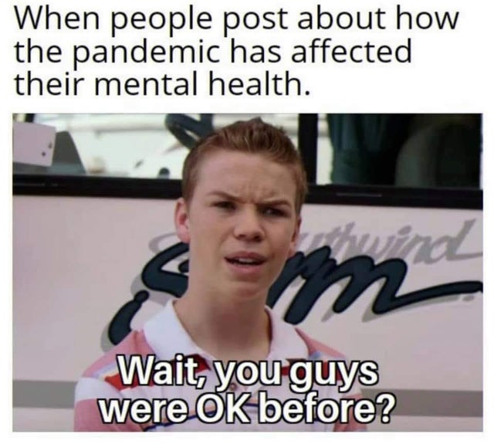

The following meme is composed of both text and a photo addressing the relationship between the pandemic and the mental health of those who lived through it. The text portion says “When people post about how the pandemic has affected their mental health”, and is responded to by the photo portion. The photo used is from a clip of a movie in which the character says “Wait, you guys were okay before?”, insinuating that some people struggled with mental health issues well before the pandemic began, which is the joke.
I chose this meme because it makes light of the hard truth that many of us struggled with mental health prior to the pandemic, and found that is worsened while being in the pandemic, even as things have reopened and attempted to return to normal. I personally think that coming out of the worst of the pandemic, and being in a weird transitional state of semi-normalcy is just as bad as being in the height of it during 2020. In March of 2020, as well as most of the rest of the year, many of us were struggling with isolation and anxiety that things would never be the same again. A lot of us who were in school initially saw it as a blessing, an extra week off from school. It was a shock to the system that we wouldn’t actually return to school until the fall of the following year. During that time, we spent our days attending class online, taking walks, binging a new show on Netflix. Life had shifted to a new routine entirely. I went from classes in big lecture halls, parties on the weekends, and watching the Bachelor on Monday nights with my roommates to only seeing my best friend in a small square on my computer screen and switching between my bedroom and the living room. It was incredibly and painfully lonely, and I think I’ll forever feel like I missed out on this monumental part of my life because of something a lot bigger than me.
Out of eight college semesters, I’ve only had three of them be completely in-person. Here I am in my last semester, feeling cheated that I lost two years of experiences and memories that I’ll never get back. I don’t even remember what my life in college was like before the pandemic, only that I had a much more positive outlook on the world and my future than I do now. I think the hardest part with being in college during the pandemic, aside from the social aspect, was that being a student became fifty times harder than it ever had been, or at least it felt that way. Professors didn’t know how to adapt to teaching solely online, and students had no idea how to adjust to a completely different learning style, I know I still haven’t. We were given more assignments, more homework, more readings to do with very little instruction on how to even be in the class, while still paying the same tuition we paid before going online. Trying to teach yourself a subject that your professor couldn’t change to fit online felt like the blind leading the blind. I don’t remember anything from the classes I took in that time because it wasn’t ever about learning, it was about knowing it well enough for the exam, passing, and moving onto the next. For that, I’ll always be a little bitter. Many say they wish we were still online and life didn’t attempt to return to normal because it better suited them, to each their own I guess. For me, I’m coming out of it with worse anxiety than I’ve ever had and no idea how to function simultaneously as an adult and student anymore. I wasn’t the most mentally and emotionally put-together person prior to March of 2020, but something about the time from then to now had changed me a lot as a person. I’m not sure exactly how to define the way things slowly and subtly changed, but before the pandemic, I never had panic attacks and I never laid in bed staring at the wall some days, thinking that responsibilities were too much and I was tired of existing. At some point during the pandemic, maybe it was when we tried to force things to be normal again before anyone was ready, daily life started to feel heavy and I felt burnt out from simply being on auto-pilot all of the time. I don’t know that I’ve really recovered from that feeling yet, and I know I’m not alone in that. Hopefully one day we can all be at peace with the way our lives unraveled in an uncertain time, no longer tired or miserable, wishing to go back to the way things were and never will be again.

