MEME ASSIGNMENT
Anonymous

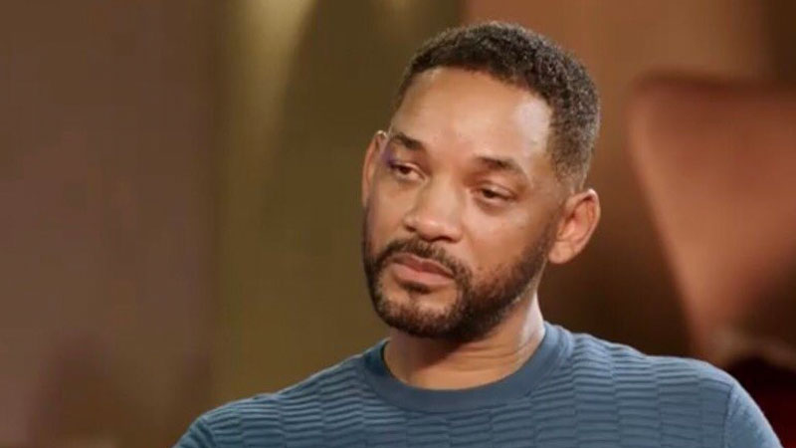

DESCRIPTION OF MEME:
This is a meme of will smith with a very overwhelmed look on his face- he looks like someone just told him something really stupid.

REFLECTION:
I chose this meme because I felt like it best represents my feelings towards this pandemic. When the pandemic first started, we were on spring break my sophomore year which was spring of 2020. I went on this trip with a friend, and as soon as we got the notification from the school stating that our “break” would get extended by an extra week, we were looking forward to an extra week to relax before the return of school. Towards the end of the extra week that was given to us, we received another notification about not returning to campus for an additional week. This is when things started to get different. After a few weeks have gone by since spring break, we realized we would now be remote for the rest of the year. I was neutral about this, I enjoyed the fact because I realized I wouldn’t have to physically get up and walk to class for the rest of the semester, but I was also bummed because this was during the beginning of the pandemic, so eventually we were limited to what we were able to do. There were strict lockdown instructions given to citizens, we had to get adjusted to wearing masks everywhere, we had to abide by a curfew. This is what make me feel like the will smith meme above. Everything was so different, we weren’t able to have as much freedom as we do now. The only thing I genuinely loved about the lockdown was unemployment. I was employed at hook and reel at the time, and all restaurants were shut down so that led me to file for unemployment. Social distancing was interesting, I wish this was implemented before the pandemic because personal space is very important. Overall, this pandemic has set me back. I have not been as attentive in school with most remote classes, I am only completing the work for grades rather than actually learning and trying to retain the information being taught to me. Over the past two years, things have lightened up. The mask mandate was lifted to where people who didn’t want to wear them in public, did not have to. There were no more curfews, there was finally an availability of toilet tissue. Things are definitely lightening up but I do not feel like covid is ever going to go away, which again, makes me feel like the will smith meme I submitted. The only thing we can do now is adapt and adjust. I have been coping by trying to find different hobbies to do. I have been learning how to bake and make homemade soup. Socializing during covid wasn’t too much of a problem depending on how it was done. Most people I know have social media, so we would constantly see each other online, as far as socializing in public, it was kind of hard with a mask on but I still like to keep mine on to prevent exposure from the virus. I have not yet gotten COVID and I plan to keep it thay way.

