Rozwell MacLaren

ENG 3570 sec. 002

Dr Kitta

Meme Project

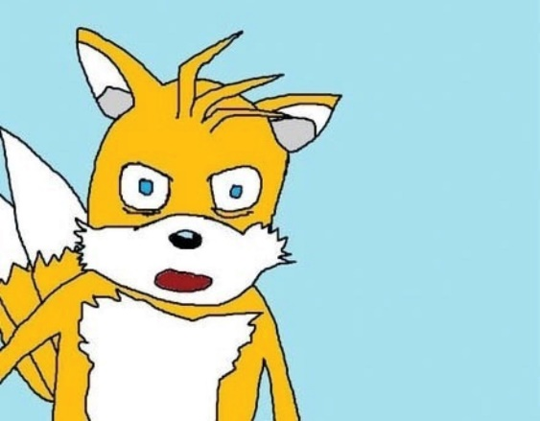

[Image Description: A poorly drawn picture Tails, from “Sonic the Hedgehog” expressing extreme shock and disgust, possibly fear as well]

This meme was chosen to represent my experience with the pandemic because like Tails, I too am experiencing shock, disgust and fear with the current situation. A lot of things have happened over the past couple years. For me, switching to remote learning was very difficult. College definitely got more difficult with the switch, and I lost all motivation to do schoolwork. I failed my first class, my grades were lower than ever, and with the quarantine, I had no schedule to keep me grounded. Thankfully I was not employed at the time, so I didn’t have to deal with job loss or being deemed as an essential worker. Social distancing did not really affect me either, since most of my friends have moved away and I talk to them and hang out with them online already. Though I could no longer visit them over the summer, which was the only chance I could. Quarantine wasn’t too difficult either, since I usually prefer to be alone anyway, but not getting to see other people or interacting with them because class was online sucked. That was where I usually got enough social interaction to keep me from feeling depressed and lonely. I am at risk more than most people because of my autoimmune disease, so it really bothered me that people wouldn’t quarantine long enough for the pandemic to die down enough where we wouldn’t still have it this bad almost 2 years later. It bothers me even more now that people are trying to pretend its over when its not. I recently as of January 2022 got the virus, but thankfully it was one of the more recent variants and did not affect me that bad. I am however terrified that since there were heart complications of the original virus, that I may be even more at risk down the line, since the newer variant hasn’t been studied as much. Thanks to this, as well as how long the pandemic has been going on, my mental health took a nosedive. I was quite depressed for a while, but thankfully I met some good people online. It helped me cope with the situation. Other things that helped me cope was keeping myself distracted with videogames, as well as making and looking at jokes about the pandemic. There were a lot of memes about how people would wear masks wrong, and entitled people trying to enter stores and being turned away when they would refuse to wear masks as well as the usual strange memes about other world events like the Ever Given, a container ship, getting stuck in the Suez canal in March of 2021, one year after the pandemic started. Still, it is terrible that the pandemic is still going on, even though people are pretending like it isn’t.

So yes, like Tails I am shocked, disgusted and afraid at what’s currently going on. I wish people had thought a little more about others and not just themselves before putting people like me in harms way. The pandemic is far from over and people like me are still at risk. I will still be wearing a mask and getting my booster shots.