Vidant Health

COVID-19 Action Report

The First 18 Months: January 2020 to June 2021

Preface

It was with great doubt that any one document can rightfully reflect Vidant Health’s response to COVID-19 and the impact to our patients, team members, organization and community. This document was written with the understanding that it would fall short of capturing the true level of personal mental stress, successes and failures of Vidant Health’s response to COVID-19. In defining Vidant Health’s pronouns this document used “We” “Us” and “Our” to describe the team members and organization in this document. The first impression when looking at the past 18 months of COVID-19 was the strength of our systemness. Early on in the pandemic and continuing through the pandemic there was great uncertainty and a need to learn the nature and science of this outbreak to best create policies to contain the outbreak. We found strength in our systemness to face many of these unknowns and provide needed healthcare to our community during these challenging times.

Vidant Health COVID-19 Facts as of June 30, 2021

766 COVID-19 related Deaths reported by Vidant Health

5,275 COVID-19 Related Hospitalizations

36,526 Patients with positive COVID-19 tests

451,024 COVID-19 tests resulted

Emergency Planning

Hospital plans were in place before the pandemic. Emergency plans for events such as managing hurricanes, ice storms, loss of utilities and loss information systems had been used to manage past events. Vidant Health had plans and properly managed the H1N1 pandemic in 2009. The basic plan for hospital pandemic management was “Influx of Infectious Patients” plan. This plan covered everyday information gathering and surveillance for potential public health threats, plan activation, communications, supplies, patient management, personnel, visitor management, ethics, facility security and training. Pre-pandemic many hospital resources were focused on preparing for a potential Ebola patient with complex PPE, donning and doffing. A system-wide COVID-19 plan was prepared by Infection Control, but due to the fast moving dynamic of ever changing recommendations this meant that a truly comprehensive COVID-19 plan was not completed, and existed as a collection of smaller COVID-19 plans to meet the just in time demands.

Information Sharing

Pre-pandemic the main stay of information sharing was large in-person managers’ meetings, filtering down to departmental in-person meetings. The system intranet and hospital email provided a great deal of information. At the advent of the pandemic our style of large in-person meetings was deemed unsafe and banned by hospital policy. The new meeting communications methods became Zoom and WebEx. Our leadership hosted system wide Town Hall meetings via live and recorded Zoom meetings. Smaller meeting groups adopted WebEx. This meeting format was at first awkward and often interrupted, but we became proficient users of this new medium. The VH system intranet provided COVID-19 updates and information to team members via Vidant Alert. Team members had access to “COVID QUESTIONS” an email question and answer service. Weekly COVID-19 epidemiology updates with World, CDC, North Carolina and Vidant Health information were provided to leadership and managers. Much of the day to day information sharing was handled by internet “dashboards” with minute to minute changes as patients were tested, admitted with room location and discharged. The first hospital COVID-19 dashboard was developed by IS in early May 2020 and released to hospital users June 1st, 2020. Tableau based dashboards were developed starting in July with daily updates for hospitalizations, ICU admissions, ventilator use, COVID-19-related deaths, COVID-19 testing volumes, laboratory results (inpatient, outpatient and outreach) and team member illnesses.

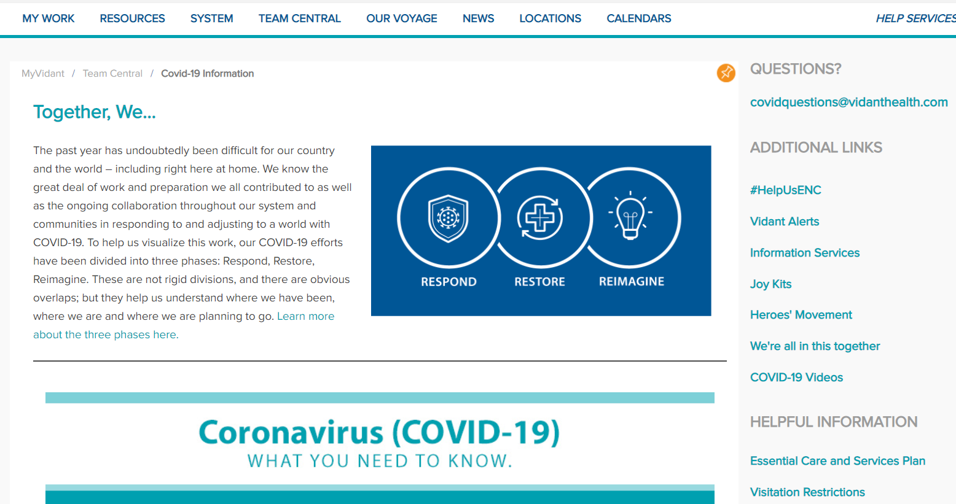

Communications with Partners

Pre-pandemic we had developed a good relationship with local Public Health Departments and the NC DHHS. Representing our 29 county region was the East Carolina Healthcare Preparedness Coalition (EHPC) which held quarterly meeting to foster communications and develop plans with EMS, Hospitals and Public Health. The EHPC also distributed and managed federal Emergency Management funding programs. During the pandemic we closely followed the CDC and NC DHHS information sites for recommendations and COVID-19 surveillance information. During the early phases of the pandemic the best sources for surveillance information proved to be Worldometer, Johns Hopkins and The Covid-19 Tracking Project. By January 2021, the CDC became a quality source for most COVID-19 information such vaccination rates, variants and worldwide cases.

A key information need was reporting COVID-19 patient test results in real time. The communication demands for timely reporting of patient status (patient under investigation or PUI), test results, hospitalizations and discharges quickly outgrew our system’s resources during April and May, 2020. The solution was provided by our laboratory and IS. Our laboratories early in the pandemic rapidly acquired the instrumentation and supplies to provide timely COVID-19 PCR test results (within 24 hours). This rapid testing eliminated the need to report the PUI cases, which many other healthcare organizations were waiting up to 2 weeks for these lab results to came back. Our IS team automated the thousands of lab results to send positive and negative PCR COVID-19 test results in real time to state and local health departments. These two actions were monumental to improving our partner communications and protecting the community.

Response

Pre-pandemic the Incident Management Style planned and trained on for an influx of infectious disease patients was based on FEMA’s HICS system (hospital incident command system). Starting in March 2020 our leadership realize that the scope of a COVID-19 hospital system response would require the entire system’s leadership team, meaning that the System CEO, Hospital Presidents and all VPs were in planning meetings, assigned COVID-19 duties and oversight. Vidant Health’s department of Systems and Procedures facilitated most of the COVID-19 planning meetings. Policy decisions were made using the latest recommendations from the CDC and NC DHHS Public Health in conjunction with the system’s subject matter experts (Infection Control, Infectious Disease, Bed Management, Patient Safety, Office of Experience, Information Systems and Pathology).

The primary mission of the hospital was to continue to provide a safe hospital environment for vital medical needs such as trauma, heart attacks and child birth while continuously adapting to serve and protect the community during the worst pandemic in the past 100 years.

Federal reporting requirements were demanding and difficult to meet. We had federal and state demands for daily reporting of hospital items such as the number of COVID-19 patients, ICU patients, available beds and COVID-19 treatments. IS provided the means by which to gather the data for each of the 20+ individual data items requested. Hospital emergency management personnel were still needed every day (including weekends) to enter the federal data.

Infection Prevention

All patients seeking medical care were first screened with a temperature check and asked about any COVID-19 symptoms. All patients were given a procedure masks and asked to wear them. Patients with concerns for COVID-19 were segregated to provide isolation and rapid lab testing. Emergency Departments also triaged suspected COVID-19 patients to designated examination areas. During the initial pandemic and peak surge inpatients, COVID-19 patients were cohorted in a patient room or unit designated for COVID-19 isolation. Hospital room assignment was handled by centralized Bed Control conferring closely with Infection Preventionists and the Infection Control Physicians. Patients on COVID-19 isolation were on contact and droplet precautions. COVID-19 patients needing aerosolizing procedures were placed on airborne precautions. No visitors were allowed on COVID-19 units (exceptions were made for dying patients). Hospital charts were automatically flagged when a patient tested positive of COVID-19. Unit nurses and physicians were charged with ensuring the appropriate isolation and conferred with Hospital Infection Preventionists to add or remove isolation.

Team Members and Staff Management

Team members were our greatest resource for managing the pandemic. During the peak of the pandemic this also proved to be our greatest limitation for providing COVID-19 patient care. It was not the lack of supplies or hospital rooms, but the lack of the nurses and physicians to provide care when the greatest surge hit in December 2020 and January 2021. VH system hit a peak of 254 COVID-19 inpatients on January 3, 2021, this was our limit.

Occupational Health played the lead role is monitoring team member health. Team members were required to wear hospital supplied procedure masks while on hospital grounds. Early in the pandemic team members were stopped at hospital point of entry, had their temperature checked and asked to report any COVID-19 symptoms. This process was replaced by an online daily COVID-19 health check. All team members were given digital thermometers and reported their temperature and any COVID-19 symptoms daily. Easy access to timely COVID-19 testing was made available to team members. Occupational Nurses were available 24/7 on call to arrange testing and care. Using guidance from the CDC, NC DHHS and local subject matter experts Occupational Health oversaw team members quarantine related to exposures, isolation, lab testing and return to work. The number of sick team members testing positive for COVID-19 was collected and analyzed using a COVID-19 TM Tracking Dashboard. Reports of team members testing positive for COVID-19 were faxed to the Local County Health Department of the team member’s home residence.

Team member COVID-19 illness rates were similar to the rates we saw in the community. Human Resources worked closely with Occupational Health to provide a fair means for Paid Time Off related to COVID-19 illnesses and quarantine. Clusters of COVID-19 illness were closely monitored and when discovered a Vidant Swarm Team collected COVID-19 testing on all team members in that work area and related patients.

Team member stress due to COVID-19 both at work and home was an item of concern. Access to Vidant Health’s Employee Assistance Program for team member’s mental health issues was promoted on the hospital intranet. A large proportion of our team members were prompted to work from home when possible. The rational for working at home was twofold, one, team members were working in a safer, less contagious space and two, to decompress the number of people in the hospital (no hospital team member transit buses, fewer people in hallways and cafeteria).

Team member moral and resiliency was a key concern during the pandemic. The local communities showed their support with flowers, signs, cards, food, well wishes on the street and frequent local news reporting. The Vidant Office of Experience promoted the Healthcare HEROs campaign. Leadership frequently visited with hospital staff and provided live town hall zoom meetings. Finally, we need to thank our team member families and loved ones for understanding the stress, sacrificing time with us, loving and supporting us over the past 18 months.

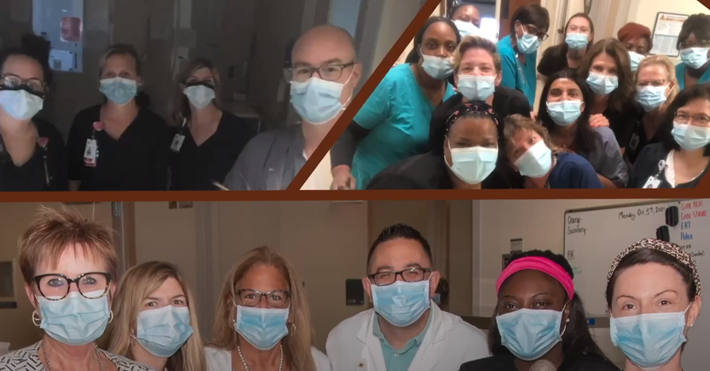

Personal Protective Equipment, PPE

During Vidant Health’s response to the COVID-19 pandemic, it was anticipated that shortages of conventional PPE were likely to be encountered. Hotel PPE was set up to centralize critical COVID-19 supply and to keep tabulation of PPE stock. To conserve PPE, modification to current PPE usage was instituted. This ensured critical PPE would be available for those caring for suspected or confirmed COVID-19 patients. Training on PPE procedures and protocols were provided via E-inform, education modules with videos, and just-in time training with front-line team members. Vendors and other sources for gloves, gowns, and masks were investigated for potential resources. Protocols and procedures developed for extended and reuse of masks and respirators until shortages had been solved. In addition, a process for decontamination of mask was developed. However, decontaminated masks were only reserved as a last resort.

Patient Well-being and Visitation

Early in the pandemic there were several months that hospital visitation was not allowed. There were a few exceptions (child birth visitation for the father and visitation in the case of a dying patient). The no-visitation rule was later relaxed to non-COVID-19 patients were allowed one visitor per day. Signage was posted at hospital entry points. The Vidant Health website kept the public up-to-date on the most current visitation rules with an online chart showing rules for 6 different types of visitation and 4 exception rules. The Vidant Office of Experience promoted and provided a means for love ones to contact patients via remote access such as cards/letters, social media and telephone. Visitors coming to see patients at the hospital were screened for a fever and COVID-19 symptoms. Visitor were asked to go directly to the patient’s room and no else within the hospital.

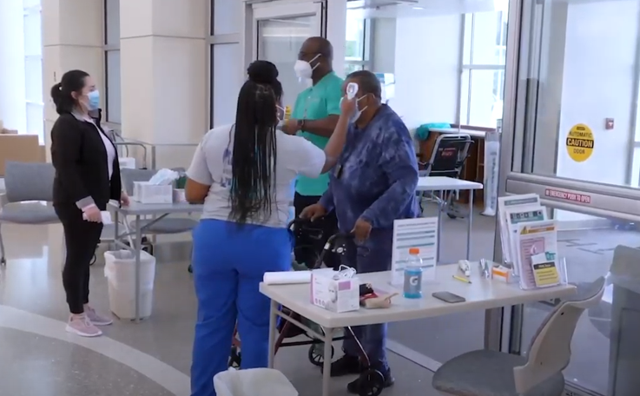

Vidant Health Case Management had a good relationship with area nursing homes and an established communication system so that patient transfers to and from nursing home facilities could be safe. Nursing homes were hit early and hard by the pandemic and many controls were put in place to slow the number of COVID-19 cases. Routinely patients ready for hospital discharge to a nursing home were tested for COVID-19 prior to leaving the hospital.

Logistics and Supply Chain Management

Pre-pandemic the hospital system had stockpiled 90 days of PPE related supplies. Due to unexpected hospital wide usage of this PPE stockpile, the supply of PPE was close to exhausted early in the pandemic. The Vidant Materials Management leadership meet weekly and at sometimes daily to discuss supply levels, alternative products and the quality of these supplies. Consideration was given to supply conservation, extended use and methods to reprocess supplies.

Laboratory Testing

Laboratory testing was a bright point at Vidant Health. Our laboratory and hospital leadership created a robust system by acquiring several platforms to conduct high volume and quick turn around COVID-19 PCR test results. We were far ahead of most hospital systems some of which were waiting over 2 weeks for testing results. Our laboratory could provide routine results in less than 24 hours and stat testing in less than 2 hours. During the early days of the pandemic all of the COVID-19 testing was centralized to the core lab at Vidant Medical Center. Specimen courier transfers from the community hospitals were doubled and tripled to accommodate timely results. During the summer of 2020, instrumentation was in place for all Vidant Community Hospitals to conduct stat COVID-19 PCR testing in-house.

The laboratory and IS created a Tableau driven dashboard to collect, monitor and analyze the testing information. Early in 2021 Vidant Health Laboratory partnered with ECU Brody School of Medicine to provide viral sequencing testing so COVID-19 variants could be monitored locally and shared with the CDC. The South African (beta) variant was an early concern locally as we saw several severe COVID-19 cases caused by this variant. UK or alpha variant dominated and by June 2021 we had discovered our first local Delta variant.

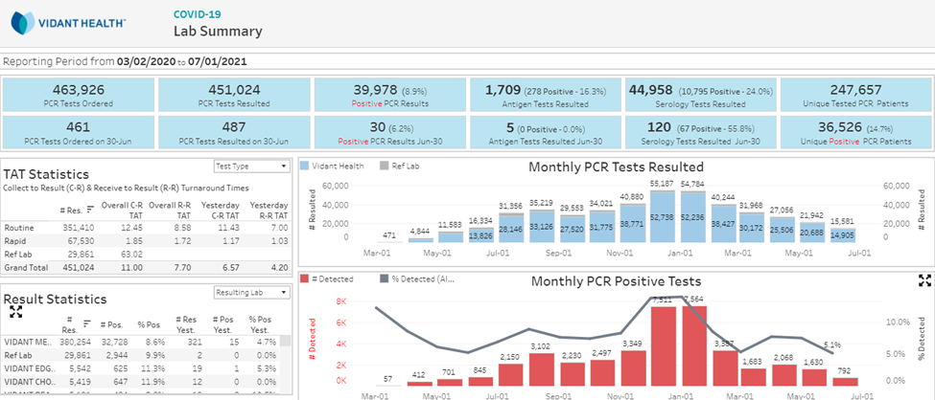

Laboratory Testing Outreach, East Carolina Testing Initiative

Vidant Laboratory and Hospital leadership pushed to increase laboratory testing capacity to a goal of 5000 tests per day. With this robust wealth of testing potential, Vidant Health began to offer convenient, drive up, community COVID-19 testing at no out of pocket costs. The laboratory testing outreach was early during in the pandemic, when testing, contact tracing and isolation were the first and only tools for slowing the outbreak. This laboratory testing outreach was the first big COVID-19 success for Vidant Health and the community. This first laboratory testing success laid the ground work for many other successful COVID-19 driven operations. The Laboratory testing outreach was supported by IS, Staffing and Plant Operations. The advent of drive-up testing created another need since most of these drive-up patients came without the relationship of a medical provider. The COVID-19 Medical Home Monitoring Team was created to support drive up patients. This team would inform patients of COVID-19 test results, isolation measures, basic self-care and connected patients with providers should their symptoms worsen.

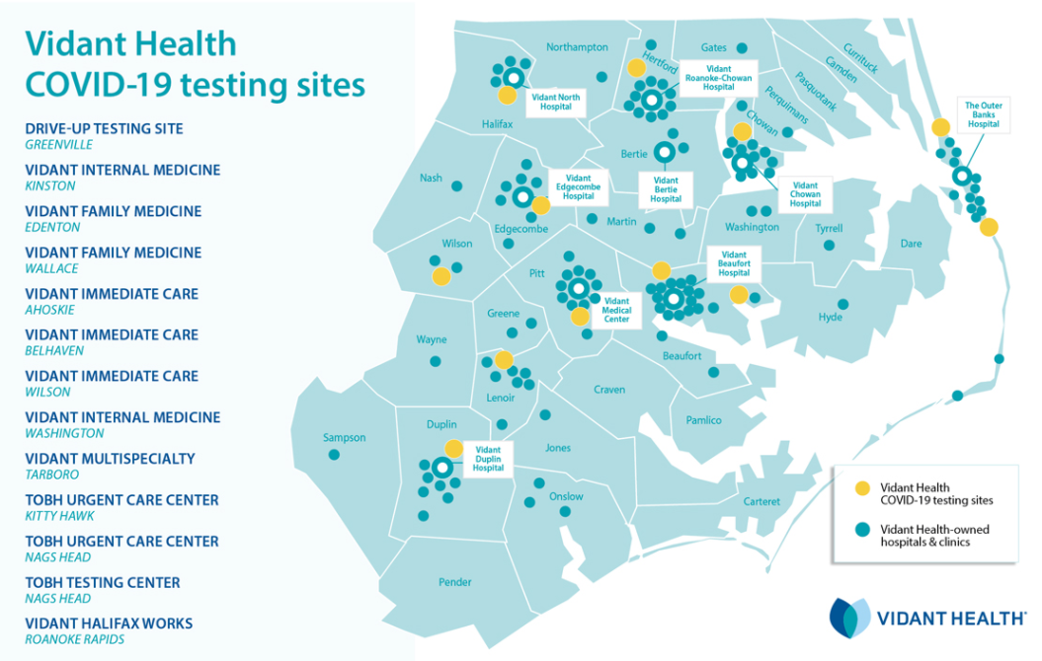

Medical Treatments and Oversight

Early in the pandemic the case fatality rate was high. Due to the learning and collective knowledge growth of our physicians and other medical providers we lowered the COVID-19 case fatality rate. Our physicians participated and enrolled patients into clinical trials. Our physician learned the value of proning COVID-19 patients and keeping patients off ventilators as long as possible. The physicians met often via remote Medical Grand Rounds Conference to discuss evolving treatments that were falling in and out of favor. Our Infectious Disease, Infection Control, Department Chiefs, Hospitalists and Intensivists Physicians were frequent speakers during these lectures. A great source of information came via the Chief Medical Officer’s Newsletter to providers. The CMO’s newsletter outlined the current COVID-19 numbers, medical treatments, admission processes, laboratory testing, vaccinations and a needed word of hope. In the light of our successes with robust COVID-19 testing, when outpatient monoclonal antibody treatments became available our system created an operation to find and enroll these potential patients who were at risk and qualified for the outpatient antibody infusions. After patients were identified and enrolled they received their monoclonal antibody infusions within Vidant Health facilities.

Vaccinations

The ground work for providing vaccinations to our team members had been well planned weeks before the arrival of the vaccines in mid-December. Vidant Health pharmacists meet with NC DHHS officials overseeing the distribution of vaccination and qualified Vidant Health as a vaccination provider. All of the enrollment items were completed. Vidant Health provided a large staff to vaccinate, document and oversee operations. Vidant Health identified team member vaccination priority groups and invited the following priority groups when appropriate. The team member vaccination program was beautifully operated with very little team member waiting. Team members were excited and grateful to be the first in the community to be vaccinated. By the time of this writing we did experience hesitancy among our team members. Our Team Members vaccination rates were normally 10 to 12% higher than the local community, but not in the >90% range as hope for. Leadership and the Office of Experience disseminated many positive messages to encourage team member vaccination.

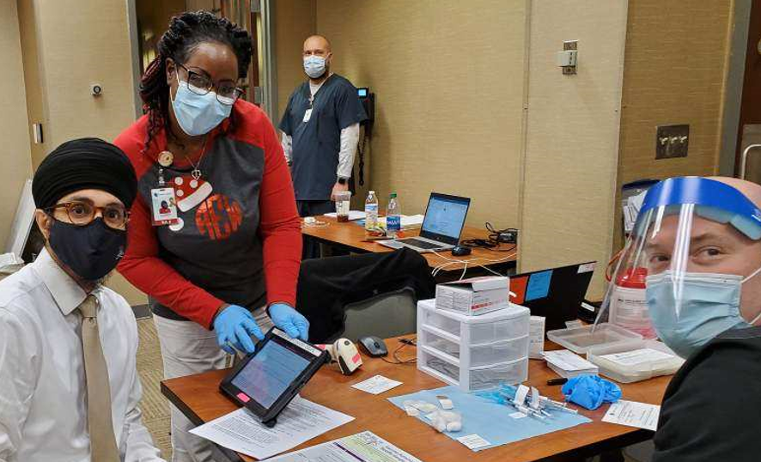

Community Vaccinations

This is one of our proudest accomplishments was providing the shot of hope to our communities. Partnering with NC Public Health and East Carolina University to operated community vaccination centers in our region. We enrolled and vaccinated thousands of people. The vaccination process was efficient, timely and well managed. A mass vaccination clinic was opened in Greenville giving over 1000 vaccinations per day on a daily basis as vaccines supplies allowed.

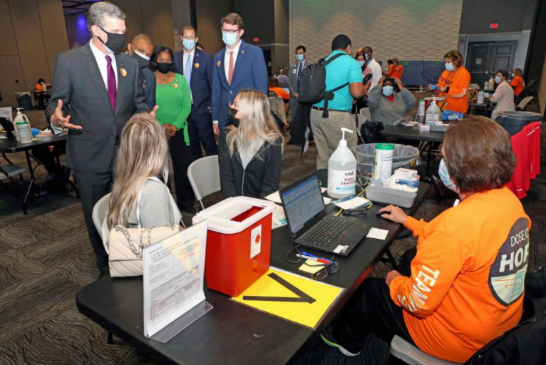

Information Systems

Every accomplishment outlined in this document was made possible or much improved by IS efforts.

* 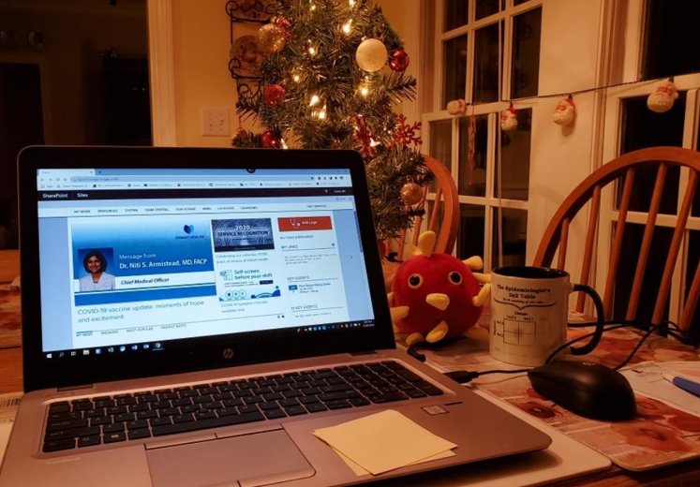WebEx and Zoom Meetings
* Laboratory specimen collections and reporting
* Vaccination documentation
* Remote access for patients to view medical records, lab testing and contact with health professionals
* Dashboards (Patient tracking, Laboratory testing, Team member illnesses, COVID-19 Variants and Vaccination Breakthrough)
* Remote team member daily temperature checks and health screens
* Implementation of Patient Isolation precautions and Infection Control monitoring
* Daily Reporting to North Carolina Public Health and Federal data systems
* Work from home

Inclusiveness and Outreach

Our vision statement is to become the national model for rural health and wellness by creating a premier, trusted health care delivery and education system. A top goal during COVID-19 was to serve all conmmunities with fairness and equality. Educational outreach to encourage COVID-19 testing and vaccination was provided to underserved communities. Vidant Health monitored health statistics related to underserved communities to ensure access to testing, vaccination and medical care. We set up mobile test collection and vaccination clinics on church grounds and in neighborhoods. We reserved a proportions of vaccination appointments for people who have little access to the internet.

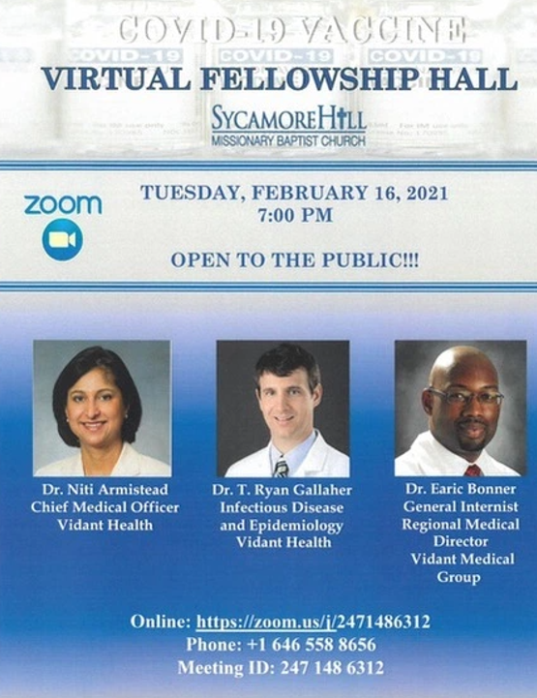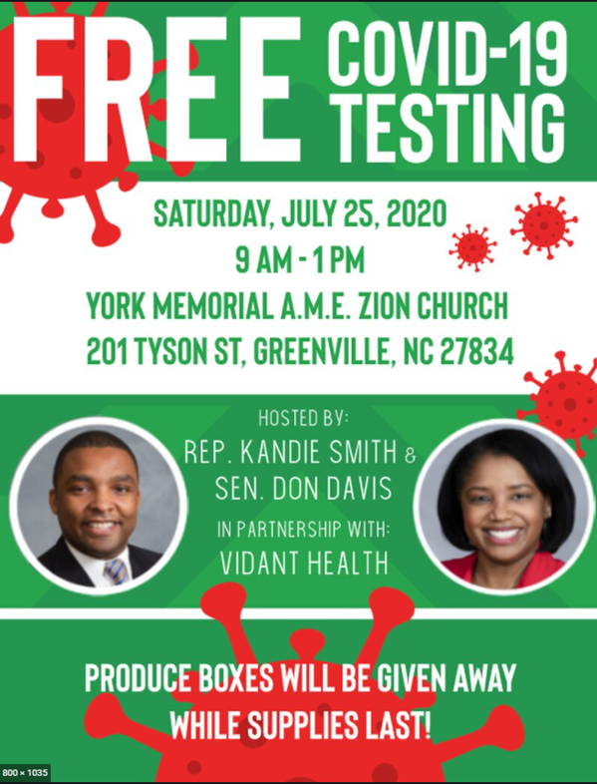

Recovery

This report covered the past 18 months. Looking into the future is difficult due to an increasing number of more dangerous COVID-19 variants and vaccination hesitancy. Overall the pandemic was well managed in an unknown situation with rapidly changing recommendations. We met our primary hospital goal to continue to provide vital hospital services while safely caring for a surge of the sickest COVID-19 patients. All team members are asked to mentally review the past 18 months with their departments and determine the items that worked well and the items that need improvements. Team members are asked to report up through your leadership chain. We are eager to return to pre-pandemic operations. Increasing vaccination rates within the community and our team members will be key to reopening. We have learned the value of face masks and social distancing to reduce to amount of respiratory pathogens transmission. This new knowledge will become part of your future hospital normal practices.

Lesson Learned

* The ability to adapt to rapidly changing situations and recommendations with fewer levels of approval
* The need to thoroughly and rapidly communicate these changes to all stakeholders
* Keeping a 90-day supply of PPE in the VH stockroom at all times
* As a system we were able to share between hospitals should one run short.

Closing Statements

Thank you to our team members. Thank you to our families and community for supporting us. If you have not received your COVID-19 vaccination yet, please help us and yourself by scheduling a vaccination appointment. In our discussions amongst ourselves, we talk about a time in the future when we will look back at this COVID-19 Pandemic and we will be proud of our efforts.