January 31st, 2023

English 3570

Prof. Andrea Kitta

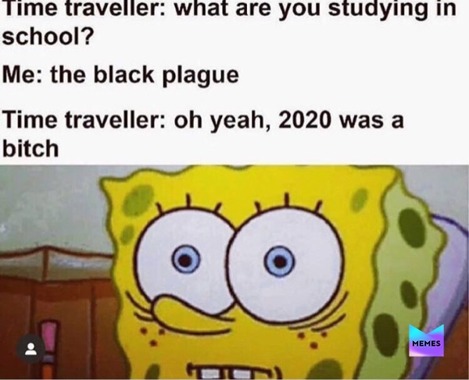
Wide-eyed SpongeBob after a time traveler is told that someone is studying the black plague, only for the time traveler to respond with, “Oh yeah, 2020 was a bitch.”

Reflection
I chose this meme because several times throughout the pandemic, I heard it referred to as the “Black Plague.” Although I didn’t experience the Black Plague, there were numerous resemblances between Covid and the Black Plague that made it feel like that time again, just modern day. Millions of people died, resources were scarce, and people didn’t follow protocols/policies. There was this constant fear that lingered on all of us. Would this ever come to an end? What if I get sick? What if someone I love gets sick? What about my social/work life? Our lives were flipped upside down and every day it got progressively worse.
I was a freshman at ECU when Covid hit. We were sent home from Spring break (my home being Charlotte, NC) and then we just never came back. At the time I was an art major and making that transition to online classes was nearly impossible. I remember being in a ceramics class and our assignments turned into, “Draw what you would have made out of clay.” Rather than handling clay and experiencing a hands-on activity. When our assignments turned into imagining what we would have done, I lost all motivation for school. I was also 4 hours away from all the friends I had made at college. I never really kept in touch with anyone from my hometown therefore being that far from the friend group I had established made it feel so lonely and more isolated. To top it off, I wasn’t a tech-savvy person. I struggled to keep up with how to work Webex and Zoom, virtually turn in assignments, set up a meeting with a professor via laptop, and keep up with due dates because I wasn’t being reminded in person. I felt as if I was falling entirely behind. That Spring semester I had basically failed all my classes because the transition to remote learning was so detrimental to how I functioned, and how I grew up learning, it destroyed everything I knew.
When we returned in the Fall, I had in-person classes for roughly a month before we all transitioned again. And once again, I failed almost all my classes. I never had a problem with social distancing or wearing a mask, but it aggravated me watching the people I was surrounded by every day not care about what was happening and how it was affecting our community. The people who chose to continue partying chose to not wear a mark, and chose to not follow policies, play a partial role in why I wasn’t academically successful for a year. My mental health and academic status were so bad that Fall semester, that I took the following Spring semester off to catch my breath and get my ducks in a row. Although it was a personal choice of mine, it almost felt unfair. I was embarrassed because I knew this all threw off my graduation date. I was afraid my parents would be disappointed in me for not graduating on time. I was scared that I wouldn’t even go back to school. I knew I was doing what was best for me, but it never felt entirely right.
At the start of Covid, I was unemployed therefore I didn’t lose a job. My parents on the other hand had to transition. My mom’s office closed, and she began working from home where to this day she still works from home, almost 3 years later. My dad was a mechanic, there was no transitioning online for him. His company closed for almost 6 months and money began to grow tight. On top of the money being tight, there were now 4 people living in my home again because I was no longer living on campus. Watching my parents panic every week about how they were going to pay bills, get groceries, having to potentially find new jobs, added to the stress of the pandemic. Everything was out of our control, and it felt like our lives were slipping away.
3 years later and I still haven’t had Covid, nor have I seen anybody I know experience a fatal level of Covid to the point of hospitalization. I personally don’t know what it is like to know that someone I love has died or been close to dying because of Covid therefore the pandemic never seemed massively scary to me. I still wanted to keep safe, I still followed the policies and I still respected people's wants/needs and I always knew it was a massive deal to our world, but it doesn’t feel like it affected me as deeply as it did others because I didn’t experience any loss in my life. I was mostly scared about how we would come out of this if we would come out of this.
Overall, the year 2020 took a lot away from me, making that year itself a
“bitch.” I was almost kicked out of school, my family was financially struggling, my mental health was at an all-time low, I was entirely alone, and the world was falling apart. Although we can sit back and joke about the pandemic now n’ days, it’s beginning to feel like the last 3 years were made up in a way. I feel as if I lost 3 years of my life, mentally and emotionally, and have had to grow up quicker than I ever anticipated.

