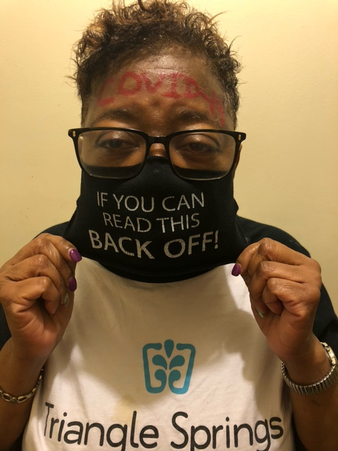

Hi All. My name is Karen Knight and I am a native of Washington, D.C.  Greenville, NC have been my home for the past 39 years. I am a proud mother of 5 beautiful children, 22 grandchildren (my 23rd grandchild due August 17, 2021), and one great-grand son. I attended Elizabethtown College in Elizabethtown, PA for one year (1978-1979), came back home to D.C. and graduated from University of the District of Columbia (1979-1982) with an AAS degree in Mortuary Science. It has always been my intention to go back to school and get my BS degree in Biology.  Family was and is my priority, so I put my dreams on the back burner.  Now I find myself closer to retirement, I decided to launch out and do what I’ve always wanted in life. I am a 60-year-old Senior majoring in Industrial Distribution, and Logistics (BS degree). I am working full time at a medical device (private) company and I have been there for over 23 years. I live a busy and full life, but I am loving it.  Last year I took a theater class, and I had the opportunity to see a few theater plays before COVID-19 shutdown the performing arts center. Going to those performances brought back sweet memories of when I used to go to the Lincoln Theater and the different museums in D.C.

When we were first mandated to wear mask as covering for protection of catching the coronavirus, I immediately decided to search the internet for the best bargains.  I search the website under Cloth Myths.com and Amazon.com. I have always been a fanatic about coordinating whatever I wore.  While searching, this mask caught my attention.  I was very curious as to how others would view the important message I as a joke or would they recognize the serious point I wanted them to grasp a hold of. To my surprise, many people approached me wanted to purchase one. It was different and unique but, it left you with a serious message. I added the red writing across my forehead to represent the seriousness of the mask.

This is a cloth mask recommended to wear.  I try to wear it as much as possible (of course without the red letters across my forehead) because there are so many Americans in denial of its purpose.  There are times when I wonder if people can read.  I have had the experience of standing in line (where marked) and others are closer than they should be behind me.  I slightly turn so they can read my mask. There are some that apologize for not maintaining the 6ft distance. Of course, there are those that refuse to keep the safe distance as well as not wearing a mask and they give me an unpleasant look.

I took this photo hoping to make a difference for someone who might have a negative attitude about wearing a mask. The quote might seem humorous, but this mask delivers an important message. Most masks are solid colors, prints, funny faces or designs.  The uniqueness of my mask delivers a is a reminder of maintaining the proper distance as well a little humor. I am a diabetic and I have high blood pressure. It is important for me to follow the 3 W’s. I have family members and friends that have had the virus and didn’t make it. Wearing the mask has become a part of my everyday living. It is working for me and I hope that others will become more vigilant of others and their surroundings and wear a mask. Think of wearing a mask as a of life saving tool and realize that you are not just saving your life, but others.