Andrea Kitta
American Folklore
2 February 2023
Covid Meme
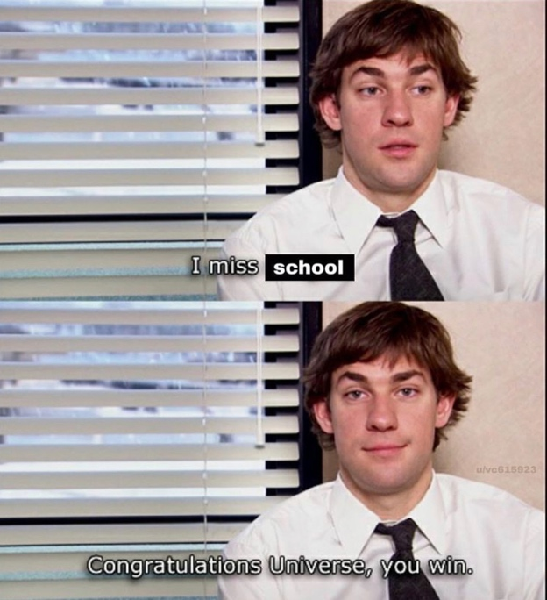

This is the meme I have chosen to reflect on, based on my experiences during the Covid-19 pandemic. To me, this meme perfectly represents the emotions I was feeling during the pandemic. I remember when quarantine began because it was during spring break, March 2020. This was the first time in my life that I recall ever having school canceled for something other than weather related issues. The first thing they did was extend spring break an extra two weeks, if I remember correctly. It was very weird because at first me and my friends had concluded that it wasn’t anything serious and that we would probably be back to school in-person in no time. This was not the case at all. After Covid reached the area, I lived in and it started to spread like wildfire, not just were I lived but in many parts of the world. The first thing I did after deciding to stay at my parents for the time being, because I didn’t have a car at the time, was to get a job. I became a nanny, for a family that had a son who was nine, and a daughter who was two. I think went and worked for a family who was five children, and they were all under ten years old at the time. I loved all the kids I worked with during this year, and I worked for them for a couple months, and would go back to my apartment in Greenville NC, as often as I could. My parents eventually got me a car, which was very generous of them, and I was able to go back to my apartment in the fall for school.
At the end of the extended spring break, school was transitioned to online learning. And it started that way for the next year and a half, for the most part. At first it seemed so nice, I would be able to stay home, not have much responsibility, and most of my classes were asynchronous, which meant they were online, and we had due dates, but all the information was given to us, and we did the work on our own time. This idea was, in my opinion, the worst possible idea they could have come up with. I have never been able to get work done that wasn’t handed to me and explained to me by a teacher or professor. I have always been the kind of person who works well with a schedule, and when there are no real things to look forward to, I become numb, and feel quite useless in the world. This leads to why I chose this meme. Not only is the meme of Jim Halpert from The Office, one of the greatest television series to ever exist, but it also does explain how I felt during the pandemic. School was harder for me than ever before, and there didn’t seem to be an end in sight. My mental health began to plummet, my depression was at an all time low. I needed that interaction, and the drive from my peers to want to do better. Being around people never felt so important. Which was funny, because now that I was in that state of mind for so long, I began to be more comfortable when I was alone, I was always very social and outgoing as a kid, and I have found since quarantine has ended, I have found more peace in being by myself. I also adopted a cat during quarantine, because I was lonely and felt I needed a companion. Two and a half years later, my cat, Stanley, is one of the nicest animals I have ever met in my life, and we have bonded so much.
Quarantine was in no way easy, if anyone says it was, they are lying. We as a species had to come together, literally, not physically, and do our part to overcome and survive the pandemic, until they found a cure, or vaccine. I was so happy when school finally went back to the way it was before, being in the classroom, and being on schedule. These are values, I never knew I had. I always took the social aspects of life for granted, and it really changed how I chose to spend my time. I show up, I am active, and I participate as much as I can, because I have seen the world change in a matter of days.

