MEME Assignment
RL
1/31/23
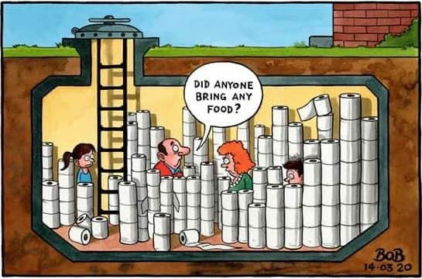
During covid 19 there was a craze where people were stockpiling toilet paper, which caused a public panic that made people feel like they also needed to stockpile. Artists made memes about this moment as a way to bring light to the world through laughter. People were scared that during covid grocery stores would shut down and supply trucks would be slower at delivering which spiked a panic around the world making people feel like they needed to stockpile as well. This was due mostly to the fact that the topic of stockpiling toiling paper was an actual thing and people felt the need to do it since others were as well.

Reflection
I picked this meme because I thought it was a funny resemblance of what happened towards the start of covid. Information about covid was just starting to come out and the public was generally not understanding of what covid was and what was happening. I think its funny how trends such as stockpiling toilet paper became popularized as public fear was at a all time high. People saw others taking part in the stockpiling and decided that the best thing to do would be to also stockpile. People were scared about the thought of self quarantining for two weeks and the ways in which they adapted to the information led to crazy trends such as this one. In some areas curfews were placed which also probably had an impact in peoples minds that made them feel like they needed to do it. Grocery stores had a genuine problem when it came to restocking toilet paper, people were fearful of not having enough toilet paper especially with the uncertainty on how long covid would actually take to be “cured” and not be an immediate threat. College students were in the process of moving online, whole workplaces were switching to allow people to work from home, and self quarantining with actual curfews were placed in some places. All of this led to the fear that the public held about supplies and other items that they could get their hands on. People would fill whole grocery carts up with toilet paper which led to everyone feeling like they needed to also do this.
To continue, meme culture loved this idea of people stockpiling, they found ways to poke fun at the way people were handling the situation. Grocery stores became mad houses at the beginning of covid as others would witness people also stockpiling and felt the need to join them in doing it. In some areas, toilet paper shortages were at an all time high, which just made people want to stockpile more for themselves because they did not know when the next time they could buy toilet paper would be.
During covid people were scared. Societies did not know exactly what covid was and the impacts it would have on the public’s mental states. There was a lot of bad information being spread on top of what was already said. Some people started to develop a fear of the government and their processes on building the vaccines. Some people were even moving away from the information top scientists were giving to people and instead chose to listen to very famous public figures that were giving out information that was just wrong. Some even quit listening to doctors entirely and were focused on the information podcasters were giving which spiked some crazy trends. The few years (2019-2022) that covid was in full effect produced some of the craziest memories I will have in my life, it also made people say some crazy stuff like the vaccines containing 5g microchips.

