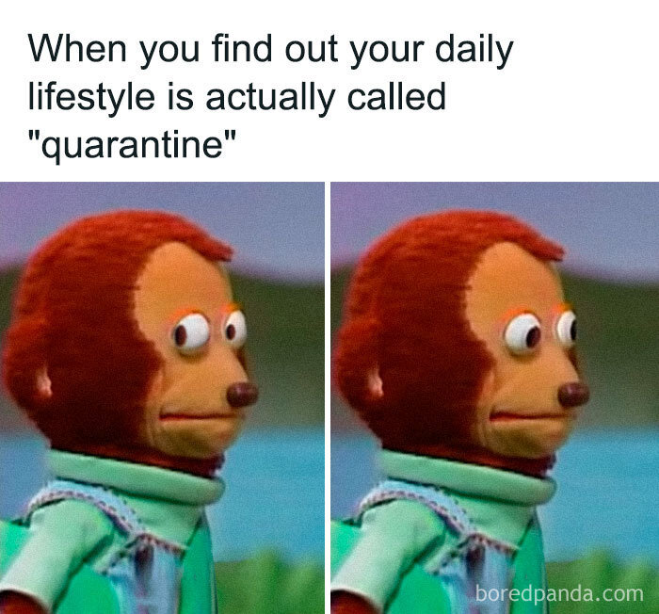

The meme above uses the “Awkward Look Monkey Puppet” template, where a puppet of a monkey nervously looks to the side in the left panel and then forward in the right. This is done to show an awkward side glance, which along with the caption is supposed to illustrate a situation where one would want to avoid eye contact. The caption for this meme reads “When you find out your daily lifestyle is actually called “quarantine.”

I chose this meme because I feel it encapsulates my experience with the pandemic pretty well. To me, this meme is from the perspective of someone who spends most of their time in their own home, rarely going outside or interacting with other people. Since this was generally looked down upon before becoming common due to the pandemic, as well as the fact that some people viewed self-quarantine negatively, someone who did so even before the pandemic would most likely be viewed in a strange way, thus the picture to go along with it. As for my relation to it specifically, around March of 2020 was when the COVID-19 pandemic started impacting areas heavily due to the highly contagious and potentially dangerous nature of the virus. My area along with many others had stores, schools, and other establishments closed down. Staying home in order to avoid other people was both encouraged by health officials and carried out by most. This meant that people were unable to hang out with family and friends at restaurants, go out to shops, or watch a movie in theaters. With this being a large change in the lives of most people, it upset many, leading to public outcry as more time passed. However, I am generally not the kind of person that hangs out with family and friends at restaurants, or goes out to shops, or watches movies in theaters. Most of the socializing I do is online, and I rarely have any reason to go out. In fact, I would say that my life was exactly the same except for school, which switched from face-to-face to online, and the fact that I had to wear a mask and stay 6 feet apart from others when I did have to go out. Online school was very interesting, going from sitting in a school desk for 8 hours every weekday to sitting in my own desk or bed for a few hours a week. I found that doing schoolwork and taking exams on my own schedule was much more efficient and helpful to me personally. I also felt that wearing a mask was not at all an issue. As such, I did not mind these changes at all, and perhaps even preferred them. I definitely feel that these opinions are in the minority, however, which is another reason why I chose this specific meme. I also recognize that the virus did not impact my family as much as it did others, which would change my opinion. On another note, I found that seeing the reactions of others on social media during early to mid-pandemic was an interesting phenomenon. Specifically, seeing everyone from all different places come together on all different platforms talking about one thing, as well as how they were reacting to/dealing with it throughout the years, was a very unique feeling that I had not experienced before. Even in early 2023, nearly 3 years after the pandemic became officially declared, with the restrictions surrounding quarantine becoming much more lenient, I still see plenty of people talking about it. I feel that this event is one that will be talked about for a while by those who lived through it.