Sophia Collins

01/29/2023

ENGL.3570.001

East Carolina University

COVID-19 Meme Project

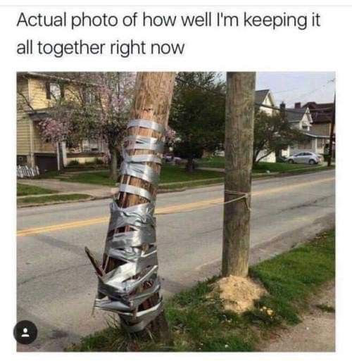

The image reads “Actual photo of how well I’m keeping it all together right now”. There is a tree that has split in half and is being barely held together with duct tape.

I chose this meme because I really identified with it during quarantine, and saved it on my phone for that reason. Quarantine was extremely difficult for me, as it was for many people. I’m an extrovert so having no face-to-face social contact was absolutely awful. I have anxiety and the state of the world and having less contact with my friends resulted in my stress levels becoming extremely unhealthy.

I love my parents dearly, but the pandemic really pushed everyone to their limit. Neither of my parents handle stress well, and they handle stress even worse together. The atmosphere in my house was so tense and my mom was especially controlling. I live by the motto of being cautious, not paranoid, but she tends to be more paranoid when things are outside of her control. Personally, I am not willing to sacrifice my mental health for long periods of time in an effort to have a better future. Especially working in healthcare, I have seen how fast things happen and how random illness and death are. I would rather be happy with how I have spent the time that I have, and hope to live as long as I can.

As much as I tried to keep myself busy by doing crafts and talking online with my friends during quarantine, it really didn’t help unfortunately. The fear and panic that everyone was feeling was so overwhelming. However, I always try to put on a brave face for those around me. I wouldn’t let myself break down and give up. There’s always hope and I did what I could to make the best of my current situation. I was barely keeping it together, and I was always stressed out of my mind. Kind of like a tree, which normally is strong and resilient, but due to some unforeseen circumstance, is barely able to stand, threatening to snap at any moment. This meme really represents how quarantine was for me because I was still functioning and getting through life, but I felt like I could break at any moment and everything would fall apart.