Kim Kassner

Dr. Andrea Kitta

English 3570

01 February 2023

Meme Assignment

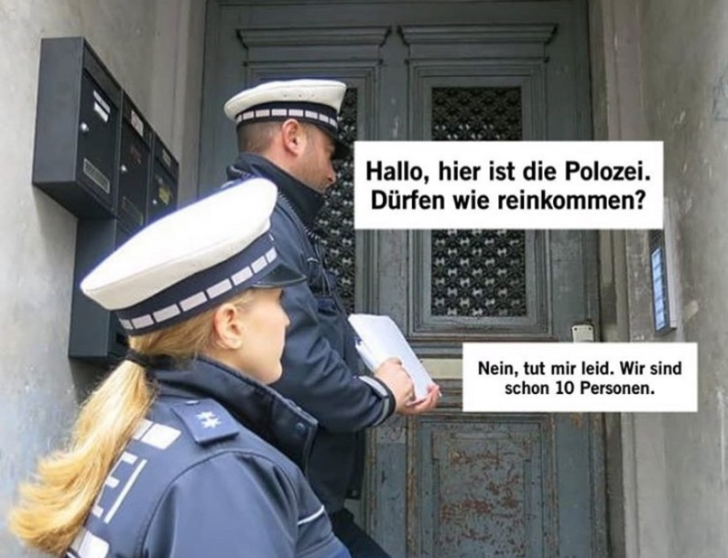

The meme shown in the picture above shows two police officers dressed in their uniforms, a man and a woman, standing in front of the main door of an apartment complex. The male police officer seems to be standing on the top of the stairs of the entryway, whereas the female officer remains on a step a little further below. Two walls, one on the right and one on left side, are framing the entrance door. On the left hand-sight, there are five mailboxes hanging on the wall. On the right-hand sight, there are five doorbells in a row with a speaking system on top of it. Both officers are faced towards the doorbells. A speech bubble is placed in front of the male officer’s face, saying: “Hallo, hier ist die Polizei. Dürfen wir reinkommen?”[1] Underneath the doorbells, there is another speech bubble, saying out of the speaker: “Nein, tut mir leid. Wir sind schon 10 Personen.”[2]

I chose this meme because it is a rather ironic response to a COVID-19 law that was passed during the peak time of the pandemic in Germany. Due to high infection rates, the German government decided to only let people gather in a group of first two, then five, and lastly ten people. According to the law, it did not matter how many different people one was meeting a day, only the amount of people getting together. The people in Germany thought the obtained law was ridiculous because it still allowed everyone in the country to meet up with a variety of people, just at different times during the day. Police officers tried their best to split groups of the maximum regulated size. However, the law contradicted the point of lowering infection rates of COVID-19, which resulted in many inhabitants making fun of what the government decided.

Personally, this meme is quite humorous to me because it represents a time of my life where I was in college. When the outburst of the pandemic happened, I was only a freshman and hundreds of miles away from my family, literally on the other side of the country. To stop the widespread of the disease, my school decided to transition from an on-campus learning facility to teaching remotely. The German government advised all inhabitants to socially distance themselves from other people and not to gather in larger groups anymore. Since most stores, facilities, and offices were permanently closed, most of my days were spent at home from there on.

The town my university is in was filled with mostly students. During the pandemic, I was living with three roommates in a flat and we were all studying in the same program. Since the program we studied was small, everyone was befriended with everyone. With the regulations of isolation being extended month to month, my roommates and I started feeling lonely and isolated. All we wanted was to be around our friends again. To increase our mental health and emotional well-being, we decided to plan bigger gatherings in our apartment so we could all socialize again. Even though it might not have been the smartest thing to do from my perspective today, being in a big group helped us all be somewhat occupied during the pandemic.

Due to the fact though that we did meet up in large gatherings, we had to hide from the frequent police controls, as well as from our neighbors. It was a constant fear of being caught and having to pay a fee for disobeying the law.

With all that being said, the presented meme is humorous to me because when the police officers ring the doorbell at the shown apartment complex, the people inside responded with: “No, we’re already ten.” This could have been a situation I might have found myself in too at some point during the pandemic.

1. *Hello, this is the police. May we come in?*
2. *No, I’m sorry. We’re already 10 people.*