2/1/2023

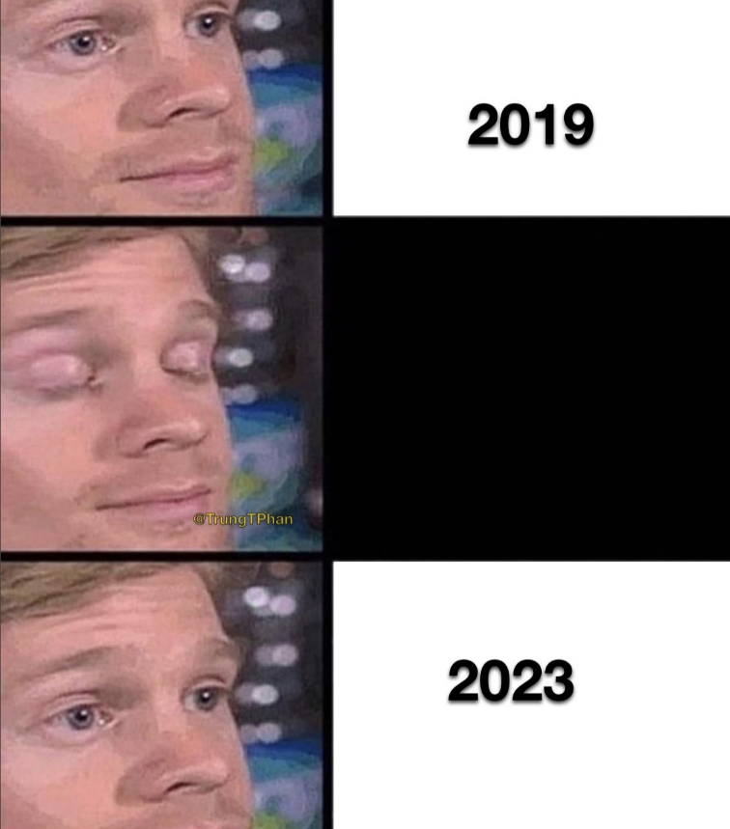

The meme above depicts a man with his eyes wide open with the text “2019” to the right, and below that is the man blinking with a blank image to the side, and the final image depicts the man opening his eyes once again after blinking, to find the text “2023” to the side. This meme is meant to represent the seemingly fast passage of time between the years 2019 and the current year 2023, in which the COVID-19 pandemic was largely in effect.

I chose this meme to reflect my experiences during the COVID-19 pandemic era for a few reasons. For those unaware, the extremely harmful and contagious COVID-19 virus started to spread in late 2019, which is the reason for the “-19” in the name but did not become a large-scale global pandemic until the middle of March in 2020. During this stressful time, everyone’s lives would drastically change as we would go into national lockdown. Schools were closed, businesses shut their doors, and many people would spend what would become the next few years stashed away in their own homes, different from the lives they used to live in the years before. As for me, I was a sophomore in high school during the beginning of the pandemic. I went to an early college high school, which means that I would end up graduating with an associate degree along with a high school diploma in 2022. As such, classes during the first two years were difficult to say the least. Having the COVID-19 virus show up and throw a curveball on my school schedule was not exactly amazing, but at least for my experiences, it actually helped me out more than I realized. I was able to work at my own pace whenever I wanted and gave me way too much free time than I needed. I pretty much didn’t leave my house for the rest of 2020, and time began to flash by in a blink of an eye. In the fall semester of 2021, now going through my first semester as a senior, I would finally be back to some normalcy going to classes in person. During the early college high school program, the last two years of schooling have us basically enroll as community college students, as we already completed most of the high school work during the first two years and official college classes would give us the remaining credit we needed to graduate. This means going back to classes in person just meant taking community college classes like any other high school graduate, which meant I spent a lot less time at school than before. So even though I was finally going outside, it did not really make a difference for me in the end. Due to this, time began to fly by as it does. Before I knew it, I would graduate high school with my diploma and associate degree as expected, enroll at East Carolina University, and finish my first semester at the institution. This allows me to get to my main point as to why I picked my specific meme to express my experiences. I, admittedly, had a lot of fun staying at home as someone who did not hang out outside for a long time anyway. Days became weeks as I would sit in my room doing countless things, not having a care for the world in terms of time. I would constantly lose track of time and forget what the day is, and I could not care less at the time. The past few years have felt like an absolute blur as my entire school and social life was practically snatched away from me, and so I was not really doing much in my spare time that I wasn’t already doing. Having nothing exciting going on can make it seem like time goes so slowly during that actual time, but as you progress to some form of normalcy, you easily forget how long time has passed. I managed to get a lot done in those years of quarantine, and it baffles me sometimes that we are in 2023 when it feels like 2019 was just a few months back. I know they say that time goes by faster the older you get, but I feel like it should not feel this fast.