Meme Assignment

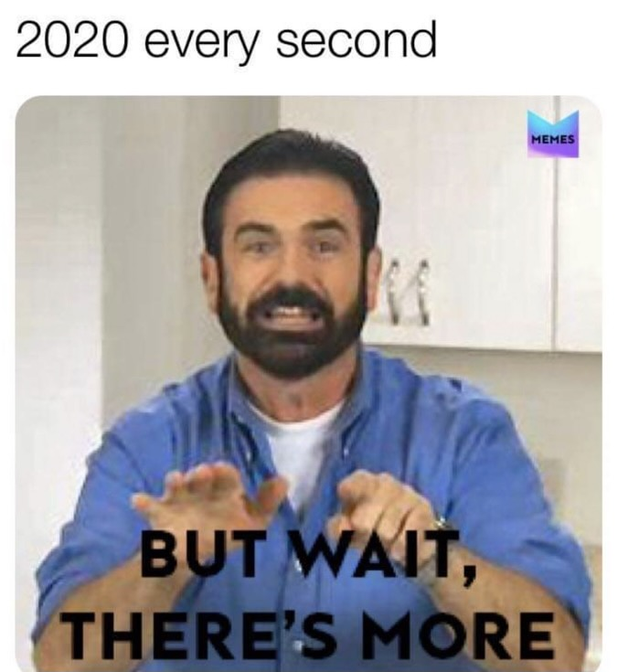

Description: 2020 every second: but wait, there’s more. This is a picture of a person who seems to be explaining something to someone, but states, “But wait, there is more”.

I chose this meme because I feel like it accurately described my life during the year of 2020. During my experiences dealing with the covid-19 pandemic in 2020, things were a little hectic. In January, the first covid-19 virus was confirmed in the United States. I was a senior in high school and graduation was soon approaching. My mom is disabled as she previously had a triple bypass open heart surgery, so my family was already nervous about what was to come. I had a feeling that schools were going to shut down, but not for the amount of time that I was imagining. Soon, we were not in school anymore and were learning remotely. I was already in a tough place mentally, and trying to find the best anti-depressant to work with that suited me and did not make me feel drained. I felt like I needed this “break”, but I did not realize I would miss out on some of the most crucial parts of my senior year, and I would no longer be around my everyday high school friends. Throughout this experience, I learned who my true friends are and who I truly wanted to keep in contact with when we went our separate ways to different colleges, the work force, and more. I learned a lot about myself and also met my soon to be boyfriend who I have been with for over two years now. I soon went to college thinking life would somewhat return to normal, but life was far from it. ECU had sent us back home two weeks into the semester, and I was back to learning remotely again with my fellow colleagues. The transition back to remote learning was fairly simple for me, as I had been learning remotely for the previous months. I was excited that I was able to return home and be with my family and friends, but also had mixed emotions as my first year of college was far from normal. I had a decent amount of friends in high school, but I was at one of my weakest points and no one seemed to notice. I felt “lonely”, but little did I realize that soon I would find peace within myself through this “covid journey”. I was enrolled in a sociology class, and I did not know how much this would broaden my perspective on life in general, as well as how we interact with each other. In this class, we were able to conversate with students from Russia, India, and Columbia via *Webex*. We all shared our experiences with covid, a broad variety of topics dealing with everyday life, and we soon realized that we related to many aspects, things, and ideas as human beings. We were able to talk about mental health and how covid has impacted us, our families, and relationships. Through the ups and downs, I soon realized that I felt way more confident in myself than I previously ever had. I guess you could say I was “thriving”. Of course there were days when I was lazy, but I lived in a secluded area where I could go on runs and not have contact with anyone. I would constantly reflect on myself and experiences because there was not much to do. Things seemed to be the same almost every day but looking back, I really developed as a person emotionally, mentally, and physically throughout the year of 2020.