COVID-19

Rachel Hobson
Department of English, East Carolina University
ENGL 1100 Foundations of College Writing
Dr. Cheryl Dudasik-Wiggs
April 18, 2021

COVID- 19 has had, and continues to have, an enormous impact on my life, my family’s life, and the lives of people across the world. Everything changed in what seemed like a split second. The way we normally would live our lives was suddenly different, from simple everyday activities such as grocery shopping, to how we attend school and our interactions with people.
As a Senior, COVID-19 ruined the last semester of my high school career. We were stripped of all our exciting senior plans like the things we had looked forward to since we were freshmen. Suddenly, there was no more prom, senior skip day, attending or playing sports, and no more graduation. We couldn’t experience the last few months of school or the following summer we had with our friends before heading off to college. Our lives just stopped in a matter of a week. The only excitement I had to look forward to was starting my freshman year at ECU. My freshman year at East Carolina has been everything except what it should have been. My roommate and I moved into Greene Dorm in August of 2020, full of hope and anticipation of starting our lives as ECU students. That lasted less than a month before we were told we had to move out.
All my classes were online, but at least I was on campus. Then in the next few months, I moved back home and continued my online courses until moving back to Greenville in January to start my second semester. Distance learning has been the most challenging part of this pandemic for me. I am not an auditory learner. I am a kinesthetic and spatial learner. I have a tough time learning new concepts by just hearing someone talk about them. I have to see someone demonstrate the skill and then do it myself. Not being able to be in the classroom with a teacher and other students has significantly impacted me academically. I have always had great grades, and I have never received anything lower than a B until we started distance learning. It has been a struggle for me to learn new material and entirely new concepts through a computer screen. I have thought a lot about changing my major if classes continue to be online next year. The courses I have to take next semester are very challenging in the regular classroom setting. If they are online, I feel I will struggle even more than I did this year.
COVID 19 has also had a tremendous impact on my family. My mom is an elementary school teacher and in August, she was told that she was being transferred to a new virtual school. My mom had already spent several weeks setting up her classroom and preparing to start the 2020-2021 school year. She has spent this year teaching second graders on Zoom. It’s safe to say it has been extremely challenging for both her and her students. My brothers have also struggled with distance learning. They both have ADD, so being at home and not in a structured learning environment has cause their grades to drop dramatically. My family is also very involved in sports. My brothers and I have always played on travel teams and school teams. When sports were canceled so abruptly, we were lost. We had never had so much free time. It was almost like we forgot how to live our day-to-day life. We had to adjust to not being able to interact with people physically. Our new normal became learning in front of a computer screen, staying six feet apart those we loved, wearing a face mask, not hugging our grandparents, and making sure we had hand sanitizer readily available.
The pandemic has changed everyone’s life. This disease has taken so much from so many. It has taken lives, independence, and sanity. I feel that the media and political antics have played a massive role in how our leaders made decisions for all of us. No matter what your political preferences are, these decisions have affected how our world relates to each other for better or worse. Yes, the disease is severe and should not be taken lightly, but responsibly. I do not believe the world should have been shut down. I agree with responsible precautions and sensible mandates being put into place. While the disease may not be as “deadly” to someone my age, we should still take precautions to protect people that it could affect.
The pandemic threw everyone for a loop in 2020, and it continues to surprise us. It has taken so much from all walks of life; yet, it has taught us all valuable life lessons. It has taught me to never take anything for granted because everything can change in the blink of an eye. It also taught me to not stress over the small things because someone else, somewhere, is having a much more difficult time than I am. It has also taught me not to be afraid to take a leap of faith and be more spontaneous. You never know what the universe has in store for you, so live your life to the fullest. A year from now, live in the moment and roll with the punches and don’t sweat the small stuff or things you can’t control.
.

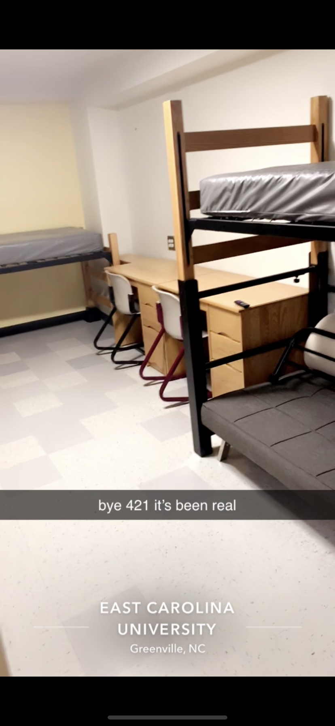
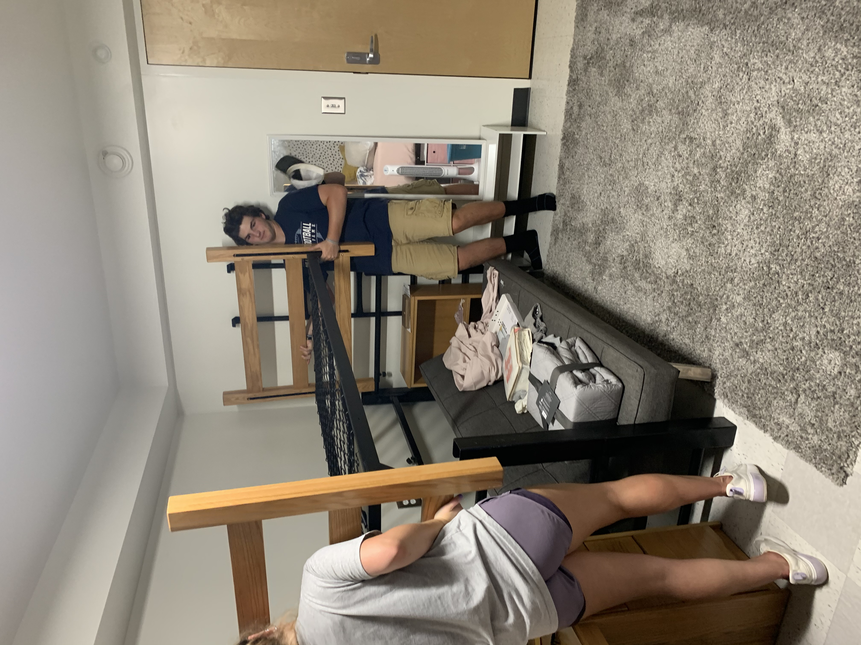
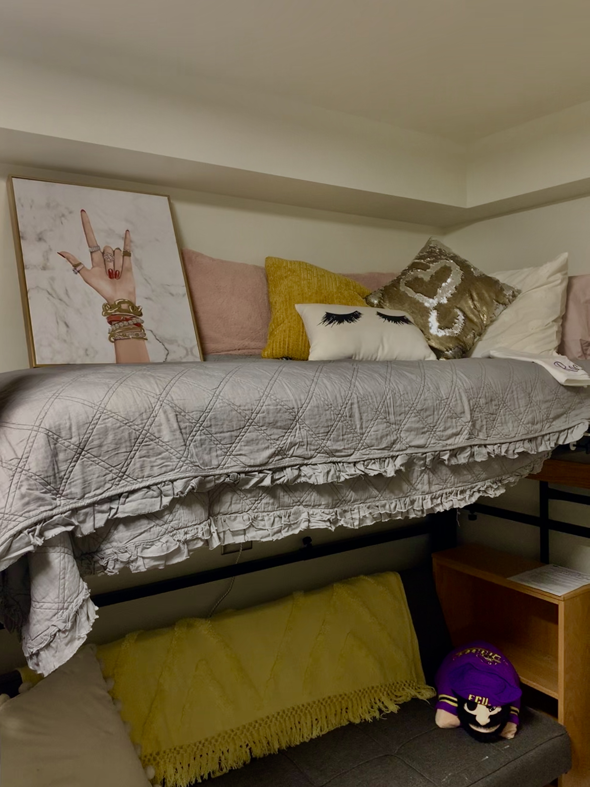
Senior Year and Freshman Year of College during COVID
