Samantha Foster

Dr. Andrea Kitta

ENGL 3570-001

1 February 2023

Pandemic Meme

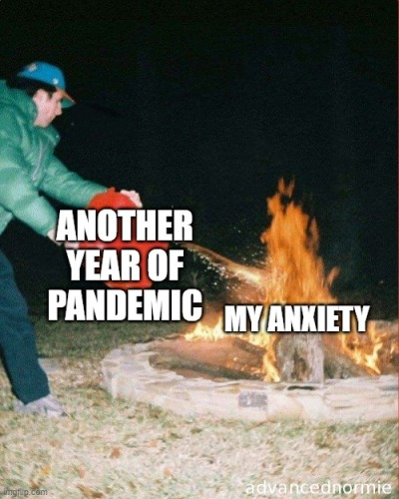

[A person in a green puffer jacket, blue pants and blue cap pouring a red container of gasoline over an already massive, burning fire located in a small fire pit. The text over the gasoline container reads, “ANOTHER YEAR OF PANDEMIC” and the text over the fire reads, “MY ANXIETY”.]

During the COVID-19 pandemic, a multitude of things changed in the day-to-day lives of the average person. In schools, students went from learning in traditional classrooms to learning online through applications like Zoom or Webex, with teachers putting their notes and problems on slides and showing them through screenshare while they taught. Many people began to work remotely instead of in the office, and those who worked for small businesses and large companies alike lost their jobs due to the virus spreading and, therefore, customer loss. Essential workers, such as nurses and grocery store clerks, had to adapt their daily routines and setups to comply with new guidelines being introduced, such as wearing masks, speaking to people from behind plastic barriers, and cleaning surfaces more often and thoroughly than ever before. People had to social distance by staying at least six feet away from one another, those who were sick had to quarantine themselves in their homes, and those who recovered from the corona virus often experienced lingering problems with their physical health. Mental health was negatively impacted for many and coping with the effects of the pandemic was difficult. Memes and jokes surfaced on the internet as a method of dealing with the boredom that came with isolation, and new ways of staying occupied at home, such as exercising or baking, were being shared online. Those who socialized did so primarily online, through phone calls, or through text. The pandemic basically changes the entire way humans communicated and interacted with the world.

I chose this particular meme to represent my experience with the pandemic in a comical yet admittedly sad way. Severe General and Social Anxiety plague my everyday life, and though the pandemic improved my mental health on the social aspect, it generally made me fearful of friends and relatives dying and of being the reason they caught the virus in the first place. I was scared to go grocery shopping or to visit anyone even when restrictions were lifted. Though the vaccine becoming available provided some temporary relief, knowing most people were choosing not to get it only increased my anxiety.

This meme, as previously stated, represents my mindset throughout the pandemic. The longer the pandemic went on, the more my anxiety grew. Even now, I still wear a mask due to numbers of vaccinated people in my area being low for fear of catching and spreading the virus to others. Like a fire being doused in gasoline, my anxiety only grew bigger and bigger the more news I read and watched about the pandemic.

The meme explains my experience with the pandemic by providing a picture of what I felt inside every day. During the pandemic, I seldom went grocery shopping unless absolutely necessary. I visited my grandma only after isolation restrictions were lifted, though I kept my distance from her and wore a mask. I did not visit my friends at all, only speaking to them through text and video chats. For most of the pandemic, I had classes online, so I lived with my parents. Their jobs filled me with anxiety, because they both worked in places with other people. My dad, who works at a steel mill, would come home and talk about how the people he worked with were not following restrictions placed for pandemic safety, which put him at risk, and therefore also put my mom and me at risk. My mom, who works as a nurse, came home from the hospital after her shifts in a change of clothes from her scrubs and would immediately head to the shower upon entering the house. Her job also put my family at risk of catching the corona virus. Every day, I lived in fear of those close to me getting sick and dying. The meme I chose sums that feeling up perfectly.