COVID-19
In so many ways Covid turned the whole world around for every single person. I can confidently say there is no one who has not been affected in one way or another by Covid-19. The world will never be the same as it was before Covid and I think when people see the vaccine and all the places lifting the mask mandates, they feel like it will but just because things are feeling more normal does not mean Covid is ever going away, especially not anytime soon. For me Covid came in waves, there were so many things I never got to experience because of Covid, but so many things I never would have experienced had Covid never happened.
I first heard of Covid-19 way back in December of 2019, and if I’m honest I did not really think anything of it because it was still isolated to Wuhan at that point. I feel like I’m not alone in that, I was definitely concerned because people were getting sick, but it just didn’t feel real because it wasn’t yet affecting me. To be honest it did not affect me till much later than a lot of other people. When Covid finally hit the U.S. I had already graduated high school because I had graduated a semester early and I was not working at the time so there was no real Covid changes that would have affected me at the time. Covid hit me at a really weird time in my life, a lot of things were already changing for me at that point and then Covid was thrown into the mix. I had just moved to Charlotte, North Carolina from Chicago, Illinois, and I was out of high school. It really felt like I had no direction in my life at that time and the world felt like it was falling apart which was really a scary feeling to have.
I really missed out on a lot because of Covid. I didn’t get a prom and couldn’t go to my high school graduation ceremony, there were a lot of big life milestones I felt like I was missing out on. If I’m honest, I was just really depressed at the time that Covid hit. I had a boyfriend at the time who lived in Chicago, so I was missing him and all my friends, but it got better when my whole family came home. My siblings all came home from their colleges because everything moved online, which sucked for them but helped me a lot. Just spending time with myself and my family really made me reevaluate what was important to me and made me so much happier. Even though the world was falling around me, it felt necessary, and it felt like the curtains were being opened on my life.
Covid forced me to be with myself more, take care of myself more and to just overall realize how much I was worth. I didn’t know I had curly hair till I was in quarantine because I never had the time to care, but when I actually had the time to take care of my hair it was like this side of myself, I never knew about. Covid really opened my eyes to things I was not changing in my life that needed change. I broke up with my boyfriend at the time and that was huge for me because I was so stuck in that relationship even though it did nothing for me. I became a better version of myself after that. Everything was better, it did not matter what 2020 threw at me, I felt myself completely. I have now done so many things that used to scare me it is crazy. I got into college, I met my two best friends, I got bangs, I finally started making music, I learned to cook and bake super well, I opened my mind to what life could be like if I just took the time to care. I even got through two semesters of online school which at many points I didn’t think would happen, but I did it and now I’m better and smarter for it.
The person I am today is unrecognizable from the person I was at the beginning of 2020 and looking back on it, I wouldn’t change anything. The good and the bad, it made me stronger, and it taught me so much about myself that I never would have learned if Covid hadn’t turned my life upside down and pushed me out of my comfort box.

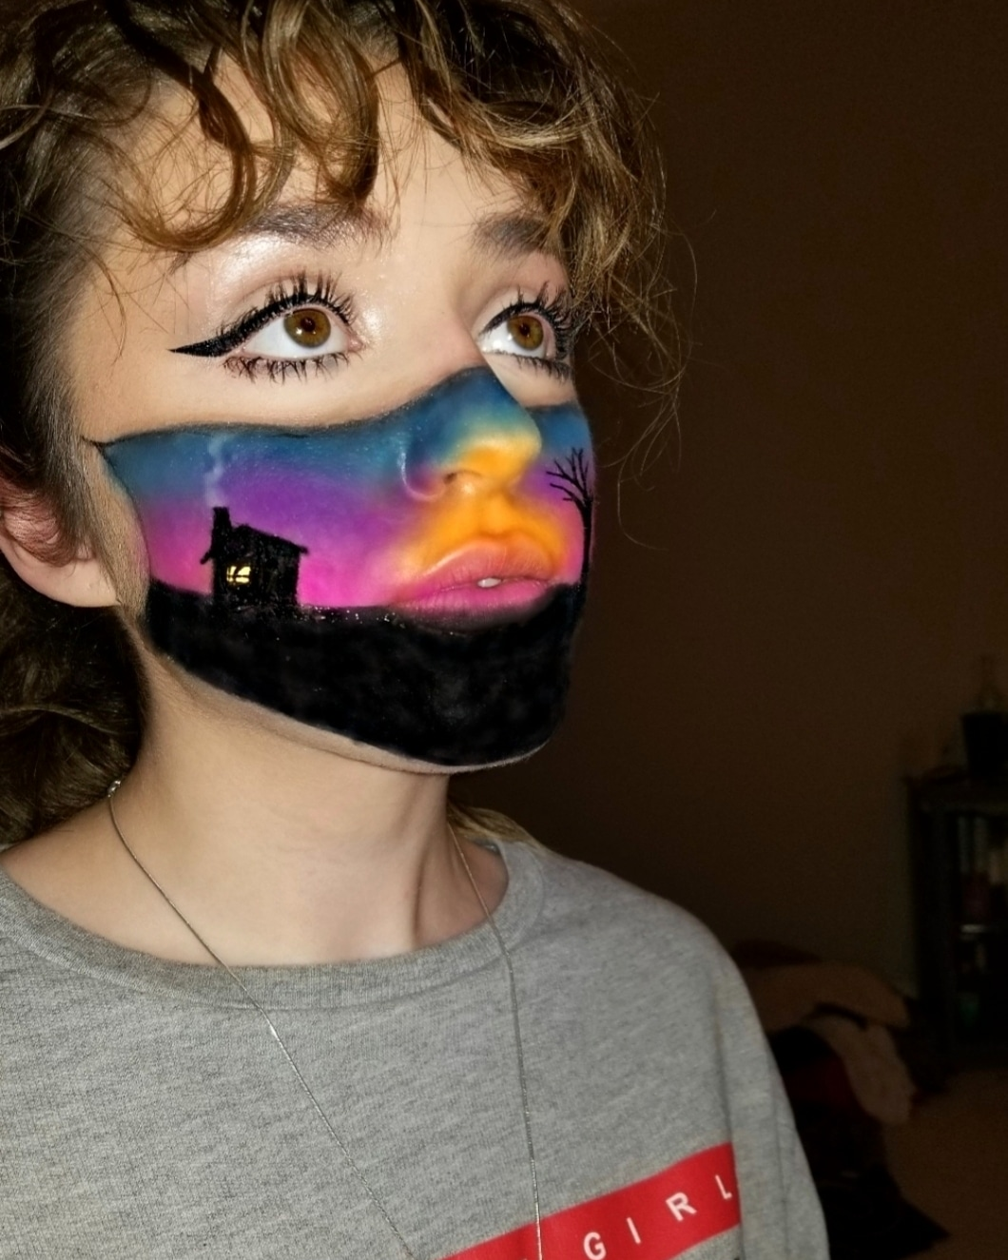
This is an art project I did During Covid. I love makeup so naturally I used makeup to create this, it represents me missing home and having to wear a mask during covid.

