COVID-19

When COVID first showed up in January, I thought it was just another virus, just like the flu, no big deal. Then when we began to see the devastation in Italy, it hit that this was not just another virus, this was not just like the flu. I took the virus seriously early on as did my mother who lived in a skilled nursing facility or nursing home. I wore and continue to wear a mask everywhere I go. She had been there since August of 2019.
The first loss to COVID was my 40th birthday trip, which was going to be to Italy. When that got cancelled, I booked a flight to France to stay with cousins, then that got cancelled. Then we went into lockdown in North Carolina. We rotated working from home and stayed home as much as possible. The virus continued to spread. New York was being ravaged right in front of our eyes on TV and social media.
I spent my birthday at home, my mom sent me a birthday wine glass from Amazon, because she was stuck in the facility and couldn’t have any visitors. Then I saw that my home county, Alamance, made the news, they were on TMZ for not shutting down and for thousands of people being at the race track with no masks. We started a reduced schedule and eventually returned to seeing patients full time with regular schedules in May. The virus continued to spread.
It made its way across our entire country, we literally had the worst COVID numbers in the world. My mother was scared that she would get the virus as it was spreading like wildfire in nursing homes. My niece made her a mask, but she didn’t like wearing it. They were testing the residents in the nursing home every week.
I and my family continued to facetime rather than see each other, I spoke to my mother daily on the phone when I got off work. Then in September, she was having sinus issues. Her test was negative. Then she started running a fever. Her test was negative. They thought she had a sinus infection and started antibiotics. Then she developed a cough. Her test was negative. They did a chest xray and she had pneumonia. They changed the antibiotics. She wasn’t getting better, so they sent her to the hospital. When she tested positive for COVID, they sent her to Green Valley Medical Center in Greensboro, an old womens’ hospital that had been converted to a COVID hospital. She told me how well they took care of her, how nice they were, how good the food was. She stayed there for 6 days getting IV Remdesivir. After 6 days, she was better and was sent back to the nursing home, she would be in a quarantine unit for 10 days. She wanted to know if her roommate was okay, but no one could tell her. She came back to the nursing home on Tuesday 9/29/20. I talked to her that afternoon when I got off work, she said she felt better, but she sounded defeated.
The next day Wednesday 9/30/20, I was at work, at ECU, when a Greensboro number called my phone. I answered and it was a doctor. She told me my mother was on a ventilator that she decompensated overnight and was sent back to the hospital. She told me that she was also on pressors (vasopressors – drugs to keep her blood pressure up) and that they had already talked to my father and decided to do comfort care. They wanted to know if I wanted to have a video visit with my mother after they extubated her. You can imagine, the shock and the pain and the heartbreak that I was feeling in that moment. I told her that I had to get home that I had to talk with the rest of my family.
I called my father who apologized for the doctor blindsiding me, but he asked her to call me when he got off the phone with her so she could explain to me what was going on. We made a plan to call family members. I cried the whole way home. I cried on the phone with my nieces when I called to tell them what was going on. It felt like I couldn’t breathe, like there was a gaping, sucking, hole in my chest and I couldn’t get enough air. I packed bags and got my dog and started the two and a half hour ride home. I cried the entire ride. I debated on going to see my mother, but they would only let me have 15 minutes as that was the limit with COVID patients and my dad and brother have flip phones, so if I drove to the hospital to see her, I wouldn’t be there to do the video visit for my father and brother.
When I got to Burlington, I decided to stay with my dad and do the video visit. The nurse called me and we set everything up, they would extubate her and call us. They called around 8:45 that night. We had a limit of four people, so it was me with my father and brother at my father’s house, my niece in Burlington with her husband and children who wanted to say goodbye to meemaw, my niece in Lillington, and my brother in VA. The nurses were so kind, they held her hand, they stroked her hair and they even sang to her. We all go to tell my mother goodbye. The staff let us stay on the video call for an hour. Then they even let my niece in TX call and have her own video visit. They let me call every hour to check on her, and after I spoke with them at 12:30, I decided to try and sleep. At 1:45 AM, they called to tell me that my mother had passed.
I woke my father up and told him, I called my brother and texted my nieces to let them know. I tried to sleep, but it wasn’t possible. Later that day, we went by the florist shop and got flower arrangements. We went to the tasty bakery in Graham, NC to get the chocolate pies my family loves so much. We notified all of our family members what had happened. The next day, we went to the funeral home and made arrangements and spoke with my niece’s mother in law who graciously decided to do the service for my mother. I went to Camera Corner to get a collage for her service, and the young man who helped me actually gave it to me for free after I told him what happened. My coworkers called and texted me. My facebook friends sent me messages. I was in such a tunnel and whirlwind of having to deal with everything and help my dad and to have that kindness and love helped me not to feel so alone and detached from reality.
We had the service on that Saturday 10/3/20 to say goodbye to my mother, a private family service that was just for us. My friend from Florida and another from Raleigh came to support me. We came back to my father’s house and ate chocolate pie and told stories about my mom and shared precious memories and it was so bittersweet. If COVID was not a thing, we would have had a normal, formal service which would have felt forced. But, because of COVID, we were able to be just the family and have a genuine remembrance of her.
I went from the shallow surface effects of COVID (losing a trip) to the most devastating loss one can possibly have to COVID and that is losing a family member. I took it seriously, my mother took it seriously and was scared to death that she was going to catch it. She did and it took her life. My mother was Ernestine Hill Webster. She was 74 years old when she died. She loved her family fiercely. She worked until she was 70 years old. She made the best spaghetti (I can’t eat spaghetti at restaurants because it’s never as good), and banana pudding. I love her and miss her every day.

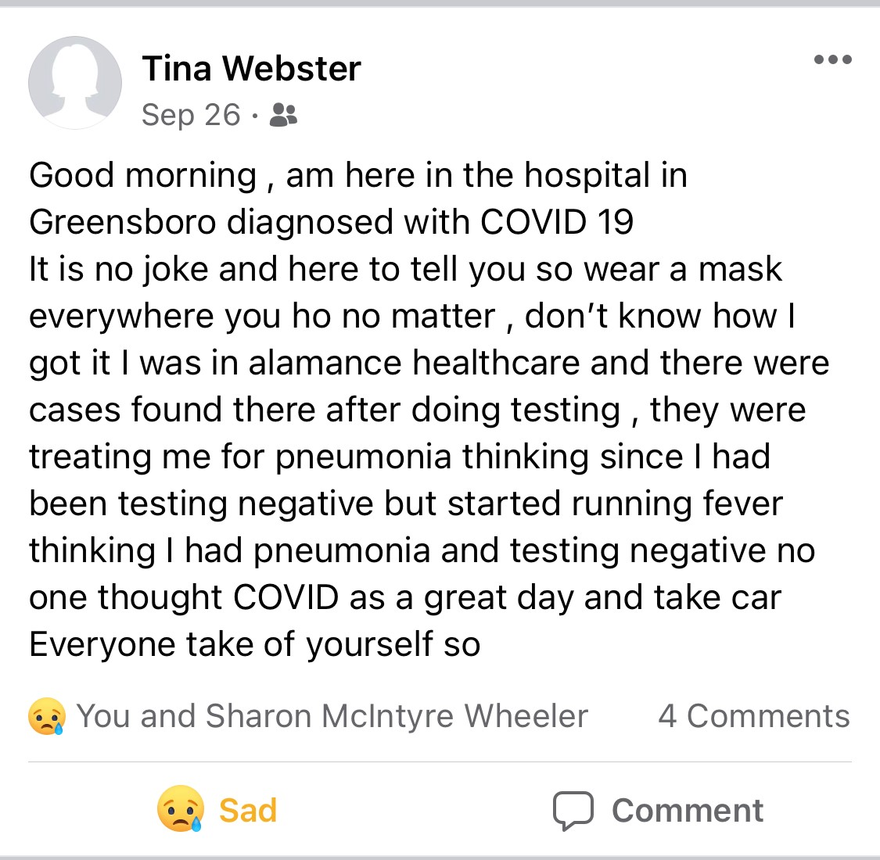
This is her last facebook post.
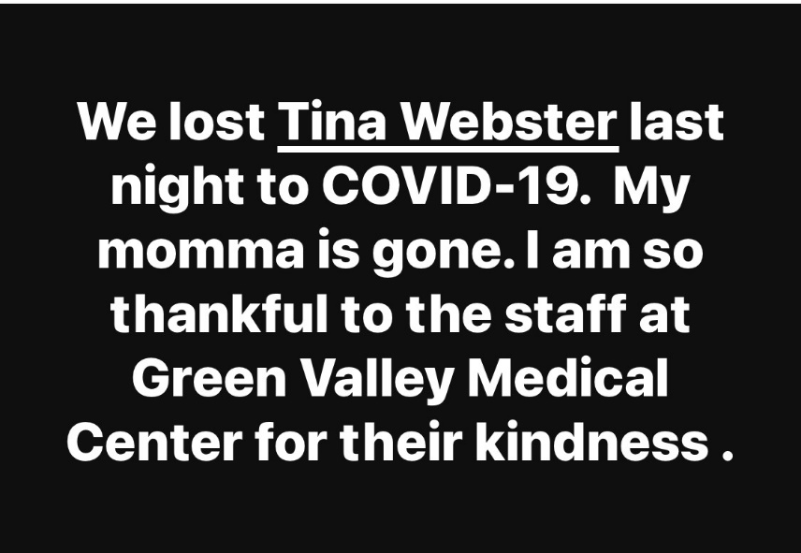
This was my facebook post

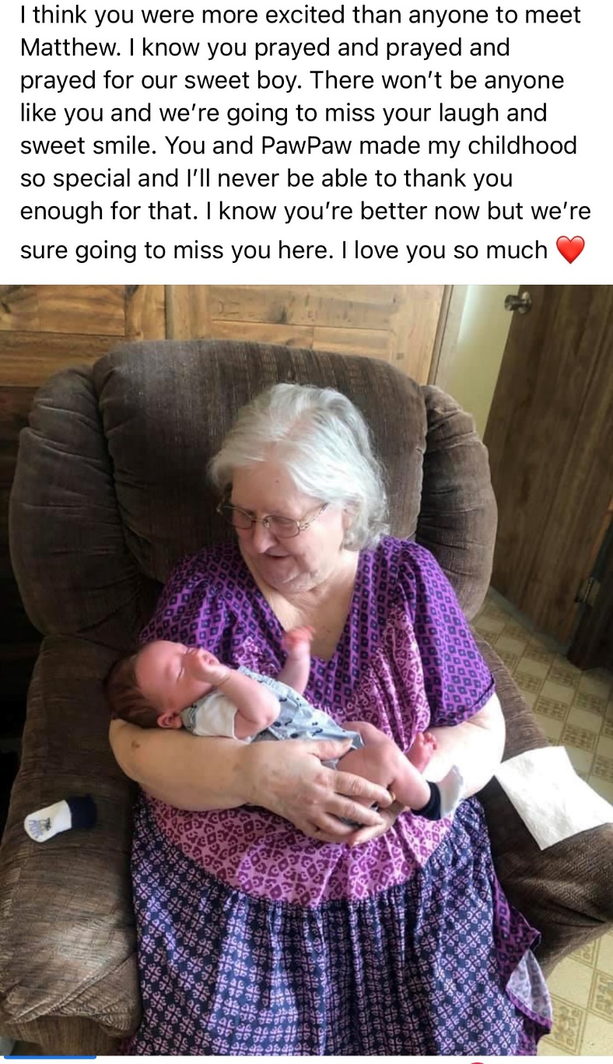
This was one of my niece’s tribute post.

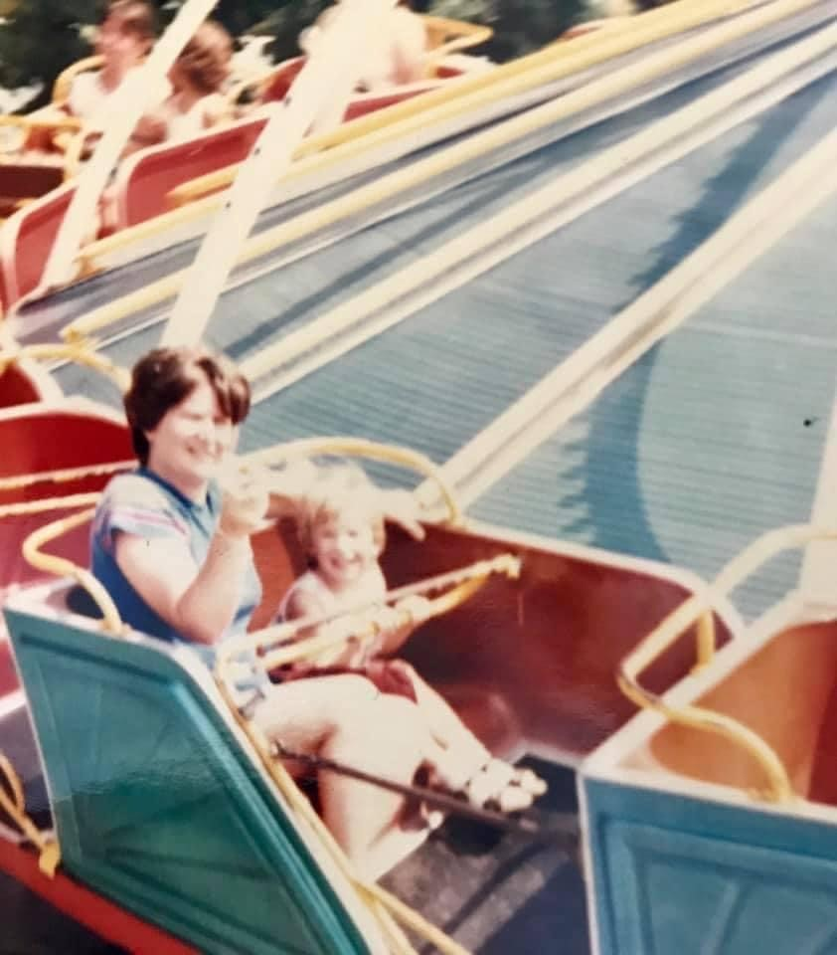
This was when my mom was at Disney with me.

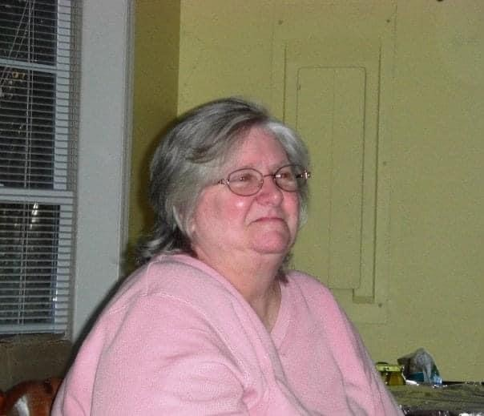
This was her at Thanksgiving several years ago.

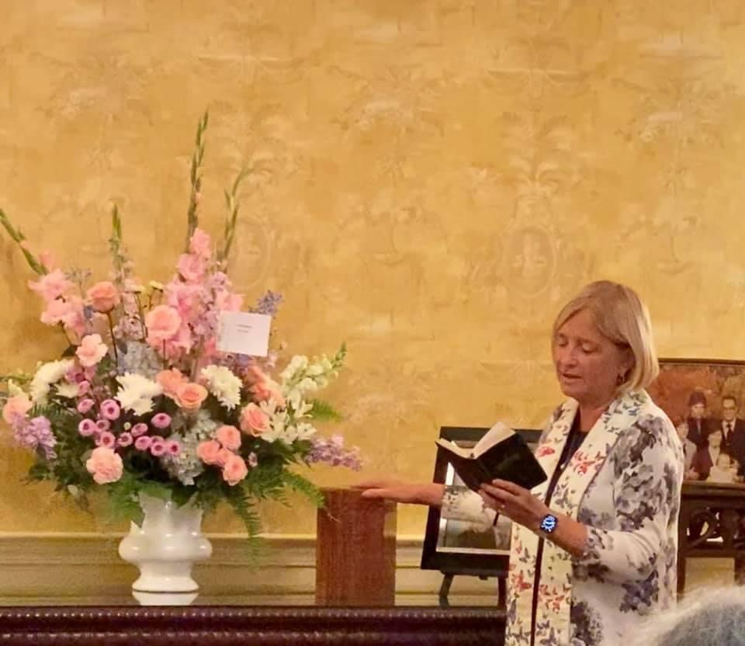
This is from her memorial service.

