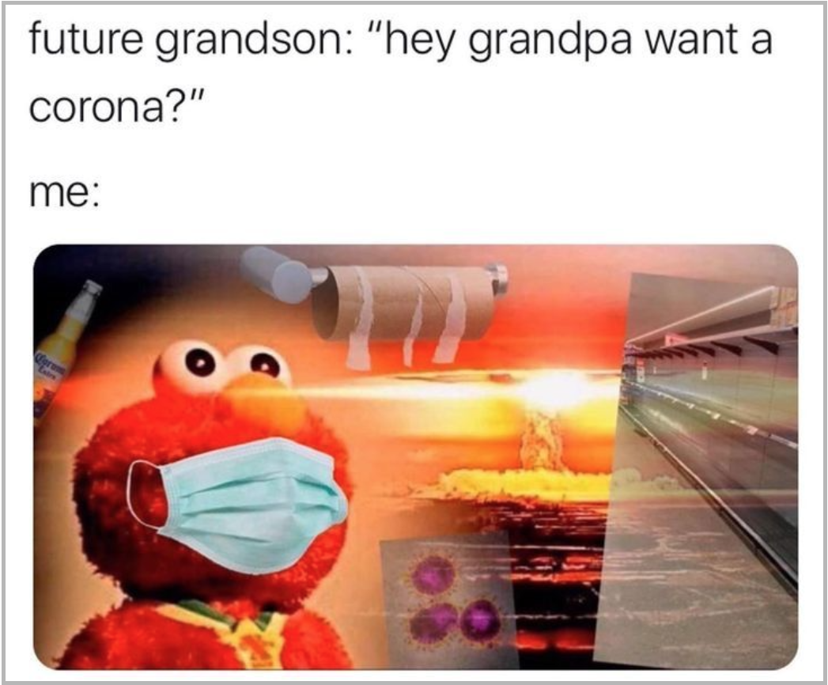

Alt Text:

Future Grandson: “hey grandpa want a corona?”

Me:....

There is a picture of Elmo, who is wearing a mask, having a flashback about covid-19 after his grandson mentioned if he wanted a “Corona'' (which is a beverage). Elmo remembers all of the terrible things such as, the stores being empty, there never being any toilet paper, how bad the covid-19 virus was, and lastly a nuclear bomb going off to symbolize what happened to Elmo's world when covid-19 “blew up” his plans.

**Reflection**

The covid-19 pandemic took away a lot of things from everyone's daily lives. School was canceled for two years and was moved to just being online school. It took away the extracurricular activities for school and everyone stayed at home. Businesses closed down for a long time and everyone had to quarantine themselves. This meme helped describe some of my experiences during the pandemic.

There were so many memes that I could have chosen to sum up Covid-19 but I ended up on this one. I think that it summarizes how I felt the best. I have always heard about how each generation has a moment that they will remember forever. For example, my parents say that their moment was 9/11. I think covid is our generation's moment. The day I remember was in March when they canceled the rest of the tennis season until further notice. We would have a 2-week break starting that day. I was very excited back then but looking at it now I wish school had just kept going. Little did we know that break would be over a year and things would never be the same. This meme took away the rest of my junior year in high school and it took away a lot of important parts of my senior year as well such as my soccer season, my school's prom both years and more things. I wasn’t able to go out with friends as much as I would have liked because everything was closed. I felt like the best years of school were taken from me in a sense and my plans were “blown up” like in the meme. I was just stuck inside for so long and nothing happened. I was just working my job at food lion day in and day out and at night I would play video games then go to sleep. The next day I would wake up and repeat.

Another thing that I remembered was laughing at memes on my phone about people in other parts of the world freaking out about the pandemic and buying all of the toilet paper in the WHOLE STORE! I mean why. I laughed at them because I thought it was so stupid and that would never happen where I lived. Boy was I wrong. I work at Food Lion, and we never had any toilet paper. For 2 years we were constantly out. I never understood why people chose toilet paper to freak out about. I thought it would be something more important such as nonperishables. Those could last a long time. But no, we always had canned food in our store.

I did learn a lot of things about myself during quarantine .One of those things was about how much I prefer in class teaching over online teaching. For online classes it was always really hard for me to pay attention most of the time when it came to lectures. But I did get better at this overtime. The main thing that was hard was that if I had trouble on something like a math problem I could not get help. It was like I was teaching myself the material which isn’t so bad for a lot of classes but in some of them I needed help that I couldn't get. Emailing teachers took forever and if they did sometimes their email would.t answer the whole question and I would have to send them another email. It also felt weird just not going to school. I didn’t realize all of the little things I would miss about in person classes such as going to lunch with your friends, meeting them between classes, and just goofing off every now and then.