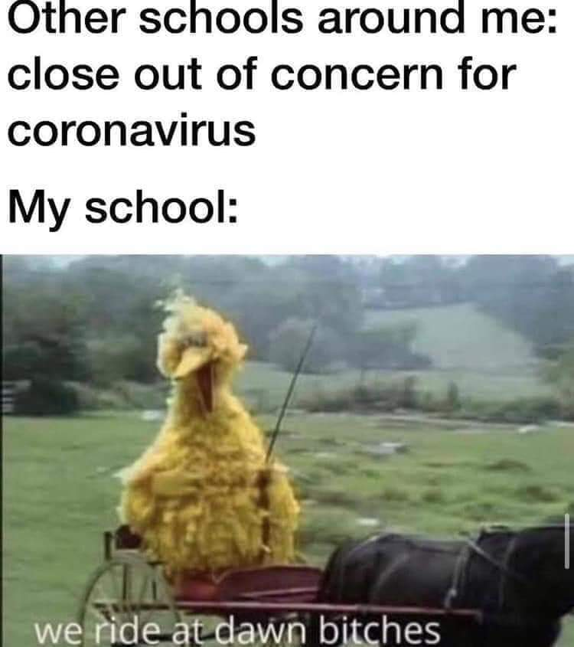
Description: Many schools have chosen to shut down keeping online classes during the coronavirus pandemic, yet our school has steadfastly refused to do so. This is the situation of the picture shown above.
How has Covid-19 impacted our life?
The reason why I chose this meme is that it represents how I feel the best. I know our school, East Carolina University, was also closed at the beginning of the outbreak of Covid-19. But that may not be enough for me. It wasn't out of a desire to be funny or to be lazy and not go to school. Rather, being an international student does come with many inconveniences. The impact of the epidemic on me and even on our family has been tremendous.
At the beginning of 2020, the whole city lockdown and the school closed in March. My boyfriend was in Orlando and my parents were in California. As an international student, most of my classmates graduated and left ecu. And because of the epidemic, basically no international students would consider studying abroad anymore, especially in smaller cities. I didn't have many friends or relatives around me at that time, and I felt really anxious about being in self-imposed isolation at home every day. Especially when I was facing the epidemic, I was very serious about it. A lot of American students were partying and hanging out everywhere as usual, constantly confirming their diagnosis, but I didn't dare to do that.
I am an international student from China who has been coming to ECU for several years, and before that passed the ESL (a language class) test at ecu's language school before I was officially enrolled. I'm from China, or more precisely from Wuhan, the city where the coronavirus massively outbreak. But don't worry, I haven't been back to China since 2018.
Because my uncle was diagnosed with the virus in Wuhan, and he was in the hospital for a few months. The disease could be said to be quite serious, and within a few days after it was first discovered, he had to travel with the help of a wheelchair, and later he was on a ventilator. He told us later, after he had recovered, that the patients in the bed next to him, upstairs and downstairs, were dying every day, and he was especially afraid that he would not be able to survive from this epidemic. We were all very worried about him, but fortunately he recovered and became a volunteer to help more people suffering from the new coronavirus. Because of him, our family took the epidemic very seriously, and we have been very strict in our epidemic prevention measures. Because I was too cautious for a while, it caused me to become a little autistic. And when I finally got used to the online classes and decided to go to California to take ECU’s online classes with my family, ECU canceled the online classes.
The prolonged epidemic has made everything difficult. As an international student, I was paying close to $14,000 per semester for tuition. And as a direct result of the epidemic, my family and I had severe financial hardships. In addition to this, I have started to keep my distance from friends who are often in close contact with others. When looking for roommates for housing, I'm also particularly afraid of meeting people who like to party. Another inconvenient point is that as international students we have to maintain at least 9 face-to-face credits and remain full-time students to maintain our visa, so I have no choice and have to keep separately with my family and boyfriend.
During the epidemic, I felt the hardness of life and experienced many hard moments alone. But I also gained the ability to take better care of myself. I have moved twice and had a car accident, but I found that there is no problem that I can overcome it if I try to face it positively. I also made two new friends last semester because I returned to campus. I don't just rely on Chinese friends anymore; I am getting more and more open minded. Some experiences will change a person's mindset, but when you face the world positively, everything will eventually develop in a good direction.

